**SUPPLEMENTARY INFORMATIONRebound effects may undermine benefits of upcycling low-opportunity-cost feed as animal feed in China**

Weitong Long1,2, Xueqin Zhu1*, Hans-Peter Weikard1, Oene Oenema2,3, Yong Hou2*

1Environmental Economics and Natural Resources Group, Wageningen University, Hollandseweg 1, 6706 KN Wageningen, The Netherlands

2State Key Laboratory of Nutrient Use and Management, College of Resources and Environmental Science, China Agricultural University, 100193 Beijing, China

3Wageningen Environmental Research, 6708 PB Wageningen, The Netherlands

⁎ Corresponding author at: Wageningen University, 6706 KN Wageningen, The Netherlands; China Agricultural University, 100193, Beijing, China.

E-mail addresses: [xueqin.zhu@wur.nl](mailto:xueqin.zhu@wur.nl) (X. Zhu); [yonghou@cau.edu.cn](mailto:yonghou@cau.edu.cn) (Y. Hou).

Contents

Supplementary Methods 6

*Objective function* 6

*Utility function* 6

*Production function* 6

*Balance equations* 8

*Budget constraint* 12

*Model calibration* 13

*Definition of scenarios* 13

*S0 - Baseline* 13

*S1 - Partial use of LCFs as feed* 13

*S2 - Full use of LCFs as feed* 14

*S3 - S1 + A modest emission mitigation target* 14

*S4 - S1 + An ambitious emission mitigation target* 14

Supplementary Results 15

*Results related to crop production* 15

Supplementary Discussion 15

*Limitations and future outlook* 15

Supplementary Figures 17

Supplementary Fig. 1 | Total (a) crop, (b) livestock, and (c) fertiliser consumption (Tg) in scenarios. Total crop consumption exclude food waste and food processing by-products used by “food waste recycling service” and “food waste collection service” sectors (see Supplementary Table 4 for detailed data). Total crop consumption includes crop used for intermediate use (i.e, feeding crops, compound feed, food by-products, processed food) and direct consumption (i.e., primary fresh food). 17

Supplementary Fig. 2 | Shares (%) of each type of feed within the total feed use for monogastric livestock production, categorized by (a) fresh matter, (b) dry matter, (c) protein, and (d) energy in China in scenarios. 18

Supplementary Fig. 3 | Changes in FCR (kg kg-1) and eFCR (kg kg-1) for (a) monogastric livestock and (b) ruminant livestock production in China in scenarios with respect to the baseline (S0). 19

Supplementary Fig. 4 | (a) Total nitrogen fertiliser use (Tg), (b) phosphorous fertiliser use (Tg), (c) crop consumption (Tg), and (d) feed demand by ruminant livestock (Tg) in scenarios.. 20

Supplementary Fig. 5 | Changes (%) in prices of factor inputs in China in scenarios (a) S1-3 and (b) S4 with respect to the baseline (S0). Changes (%) in prices of factor inputs in MTP in scenarios (c) S1-3 and (d) S4 with respect to the baseline (S0). 21

Supplementary Fig. 6 | (a) Shares (%) of each type of crop within the total cropland use in China in scenarios. (b) Changes (Tg) in crop production in China in scenarios with respect to the baseline (S0). 22

Supplementary Fig. 7 | Changes (million people) in sectoral employment in China in scenarios (a) S1, (c) S2, (e) S3, and (g) S4 with respect to the baseline (S0). Changes (million people) in sectoral employment in MTP in scenarios (b) S1, (d) S2, (f) S3, and (h) S4 with respect to the baseline (S0). 23

Supplementary Fig. 8 | Changes (%) in sectoral output (i.e., the value of production) in China in scenarios (a) S1, (c) S2, (e) S3, and (g) S4 with respect to the baseline (S0). Changes (%) in sectoral output (i.e., the value of production) in MTP in scenarios (b) S1, (d) S2, (f) S3, and (h) S4 with respect to the baseline (S0). 24

Supplementary Fig. 9 | Changes (billion USD) in sectoral value-added (a) in China and (b) MTP in scenarios with respect to the baseline (S0). 25

Supplementary Fig. 10 | Shares (%) of sectoral value-added in (a) China and (b) MTP in scenarios. 26

Supplementary Fig. 11 | (a) Absolute changes (billion USD) and (b) relative changes (%) in GDP in China in scenarios with respect to the baseline (S0). (c) Absolute changes (billion USD) and (d) relative changes (%) in GDP in MTP in scenarios with respect to the baseline (S0). 27

Supplementary Fig. 12 | Changes (%) in (a) household welfare and (b) household expenditure in China in scenarios with respect to the baseline (S0). Changes (%) in (c) household welfare and (d) household expenditure in MTP in scenarios with respect to the baseline (S0). 28

Supplementary Fig. 13 | (a) Economy-wide emissions of greenhouse gases (Tg CO2-eq), (b) acidification pollutants (Tg NH3-eq), and (c) eutrophication pollutants (Tg N-eq) in China and MTP in scenarios. 29

Supplementary Fig. 14 | Changes in crop emissions of (a) greenhouse gases (Tg CO2-eq), (b) acidification pollutants (Tg NH3-eq), and (c) eutrophication pollutants (Tg N-eq) in China and MTP in scenarios with respect to the baseline (S0). Changes in livestock emissions of (d) greenhouse gases (Tg CO2-eq), (e) acidification pollutants (Tg NH3-eq), and (f) eutrophication pollutants (Tg N-eq) in China and MTP in scenarios with respect to the baseline (S0). Changes in non-agriculture emissions of (g) greenhouse gases (Tg CO2-eq), (h) acidification pollutants (Tg NH3-eq), and (i) eutrophication pollutants (Tg N-eq) in China and MTP in scenarios with respect to the baseline (S0). 30

Supplementary Fig. 15 | Changes (%) in sectoral prices in scenarios (a) S1-S3 and (b) S4 with respect to the baseline (S0). 31

Supplementary Fig. 16 | Composition of food availability (%; kcal capita-1 day-1) in (a) China and (b) MTP in the baseline (S0). Changes in food availability (kcal capita-1 day-1) in (c) China and (d) MTP in scenarios with respect to the baseline (S0). 32

Supplementary Tables 33

Supplementary Table 1 | Summary of key assumptions used in scenario narratives and compensatory measures in China. 33

Supplementary Table 2 | Physical quantities (Tg) in fresh form for each product in China (CN) and its main food and feed trading partners (MTP) in S0. 35

Supplementary Table 3 | Utilisation rates (%) of food waste and food processing by-products in the baseline (S0) for China. 36

Supplementary Table 4 | Physical quantities (Tg) of food waste and food processing by-products and their utilisation in China in S0. 37

Supplementary Table 5 | Prices of food waste recycling service and food waste collection service in China. a 38

Supplementary Table 6 | The economic and mass allocation of food processing main and by-products. a 39

Supplementary Table 7 | Estimated mean dry matter (DM, %), crude protein (CP, %), and energy (MJ kg DM-)contents of feed sub-groups in China (CN) and its main food and feed trading partners (MTP). a 40

Supplementary References 41

Appendix Tables 44

Appendix Table 1 | Sectoral aggregation scheme. 44

Appendix Table 2 | The social accounting matrix in the base year of 2014 for China (million $).a 47

Appendix Table 3 | The social accounting matrix in the base year of 2014 for China's main food and feed trading partners (MTP) (million $).a 49

Appendix Table 4 | Emissions sources of greenhouse gases, acidification pollutants, and eutrophication pollutants across various sectors of the model. a 51

Appendix Table 5 | Total emissions of greenhouse gases (Tg CO2 equivalents) in China (CN) and its main food and feed trading partners (MTP).a 52

Appendix Table 6 | Total emissions of acidification pollutants (Tg NH3 equivalents) in China (CN) and its main food and feed trading partners (MTP).a 53

Appendix Table 7 | Total emissions of eutrophication pollutants (Tg N equivalents) in China (CN) and its main food and feed trading partners (MTP).a 54

Appendix Table 8 | Emission intensities of greenhouse gases (t CO2 equivalents million USD-1) in China (CN) and its main food and feed trading partners (MTP).a 55

Appendix Table 9 | Emission intensities of acidification pollutants (t NH3 equivalents million USD-1) in China (CN) and its main food and feed trading partners (MTP).a 56

Appendix Table 10 | Emission intensities of eutrophication pollutants (t N equivalents million USD-1) in China (CN) and its main food and feed trading partners (MTP).a 57

Mathematically, various ways exist to represent applied general equilibrium (AGE) models, according to Ginsburgh and Keyzer 1. To identify the optimal solution towards greater sustainability and enable the efficient allocation of resources in the economy, we used the welfare format of the AGE models for our analysis. In the supplementary information, we specified the model for our study by explicitly considering producers, consumers, production goods, consumption goods, and intermediate goods. Subsequently, we presented the calibration of our model. Finally, we provided supplementary figures and tables, along with the sectoral aggregation scheme, social accounting matrices, and emissions data for all the regions in our study.

# Supplementary Methods

## *Objective function*

The objective function "social welfare ()" is the weighted sum of the utility () of all consumers, according to Zhu and Van Ierland 2.

(1)

where is the Negishi weight of the representative consumer in each region (=China and its main food and feed trading partners (MTP, including Brazil, United States, and Canada)).

## *Utility function*

In our model, the consumer’s utility depends on the consumption of rival goods. The utility function is a Cobb-Douglas (C-D) function describing the behaviour of a representative consumer (household to maximise its utility subject to budget constraints) consuming rival goods. The utility function of the consumer in region is written as:

(2)

where consumption goods refers to cereal grains, oilseeds & pulses, vegetables & fruits, roots & tubers, sugar crops, other non-food crops, monogastric livestock, ruminant livestock, processed food, and non-food. is the consumption of the rival good in region . is the elasticity of utility concerning the consumption of rival good in region , i.e., the expenditure share of consumption good in consumption of rival goods in region , and .

## *Production function*

We present the production functions of seventeen producers, namely, cereal grains, oilseeds & pulses, vegetables & fruits, roots & tubers, sugar crops, other non-food crops, monogastric livestock, ruminant livestock, compound feed, cereal brans, alcoholic pulps, oil cakes, processed food, nitrogen fertiliser, phosphorus fertiliser, and non-food.

The production function of producer j in region i is specified as:

(3)

where is the production of sector in region . is the technological parameter of the production of sector in region . , , and are capital, labour, cropland, and pasture land inputs for production in region , respectively. , , , , , , , , , , , and are nitrogen fertiliser, phosphorus fertiliser, cereal grains, oilseeds & pulses, vegetables & fruits, roots & tubers, sugar crops, other non-food crops, compound feed, cereal bran, alcoholic pulp, and oil cake inputs for the production of sector in region , respectively. , , , , , , and are food waste (i.e., cereal grains waste, oilseeds & pulses waste, vegetables & fruits waste, roots & tubers waste, cereal bran waste, alcoholic pup waste, and oil cake waste) recycling service as feed input for the production of sector in region , respectively. (0<<1) is the cost share of food waste for the production of sector in region . (=1, 2, 3, …, 16) is the cost share of each factor and intermediate input for production, an*d* *.* (=1, 2, 3, …, 7) is the cost share of each food waste input for production, an*d* *.*

We also add several additional constraints on the production of crops (i.e., cereal grains, oilseeds & pulses, vegetables & fruits, roots & tubers, sugar crops, other non-food crops), livestock (i.e., monogastric livestock, ruminant livestock), and food processing by-products (i.e., cereal brans, alcoholic pulps, oil cakes) based on the information from the social accounting matrices (SAM) (see Appendix Tables 2-3) in the base year of 2014 for China and its trading partners.

Crops can't be produced in a 'factory-like' setting because the chemical processes within plants require specific nutrients that can't be substituted for one another. Different combinations of nutrients, such as nitrogen (N) and phosphorus (P2O5), lead to varying crop yields. Thus, we kept the total output of crop as a fixed ratio of nitrogen and phosphorus fertiliser inputs. In other words, the ratio of nitrogen and phosphorus fertiliser inputs for per unit of crop output remained constant across all scenarios. Since livestock productivity is directly tied to the protein and energy levels of feed, the total output of livestock is a fixed ratio of feed inputs. When substituting primary feed (i.e., human-edible feed crops and compound feed) with food waste and food processing by-products, we maintained the protein and energy feed supply for per unit of animal output in all scenarios to prevent imbalances between nutritional (protein and energy) supply and livestock requirements. Since food processing by-products are calculated based on the consumption of food products and specific technical conversion factors, we maintained a constant ratio of by-product output to the consumption of corresponding food products across all scenarios.

When emissions are outputs of the production process, the emissions intensities of greenhouse gases (GHGs) (, kg CO2 equivalent USD-1), acidification pollutants (, kg NH3 equivalent USD-1), and eutrophication pollutants (EP, , kg N equivalent USD-1) from producer in region are calculated as:

(4)

(5)

(6)

where is the emissions of GHGs (=CO2, CH4, and N2O emissions) from producer in region in the base run. is the emissions of acidification pollutants (=NH3, NOx, and SO2 emissions) from producer in region in the base run. is the emissions of eutrophication pollutants (= N and P losses) from producer in region in the base run. is the production of producer in region in the base run.

Next, the emissions in different scenarios are calculated by multiplying the current production level by corresponding emission intensities. The total emissions of GHGs, acidification and eutrophication pollutants from all producers in region are calculated as follows:

for emissions of GHGs = CO2, CH4, and N2O emissions

(7)

for emissions of acidification pollutants = NH3, NOx, and SO2 emissions

(8)

for emissions of eutrophication pollutants = N and P losses

(9)

where , , and are the total emissions of GHGs, acidification and eutrophication pollutants from producer in region , respectively. , , and are the GWP, AP, and EP equivalent factors based on Goedkoop, et al. 3.

## *Balance equations*

In our applied model, we consider factor inputs (i.e., capital, labour, and land) to be mobile between different sectors but immobile between China and MTP. Cereal grains, oilseeds & pulses, vegetables & fruits, roots & tubers, and other non-food crops are used for direct consumption and intermediate use for monogastric livestock, ruminant livestock, compound feed, food processing by-products (i.e., cereal bran, alcoholic pulp, and oil cake), and processed food production. Food processing by-products (i.e., cereal bran, alcoholic pulp, and oil cake) and compound feed are produced for intermediate use for monogastric livestock and ruminant livestock production. Monogastric livestock, ruminant livestock, processed food, and non-food are used for direct consumption. Nitrogen fertiliser and phosphorus fertiliser are used for cereal grains, oilseeds & pulses, vegetables & fruits, roots & tubers, and other non-food crops production but not for consumption. We note C for consumption, XNET for net export (exports minus imports), and Y for production. Variables with a bar stand for exogenous ones.

International trade is modelled using the assumption of perfect substitutes between domestic and imported goods, adhering to the Heckscher-Ohlin assumption 4. With this assumption, production will take place in countries with comparative advantages, meaning goods will be produced in the countries that can produce them most efficiently. To prevent a strong specialisation effect under free international trade, which could reduce some goods' production to zero in a certain region, we set a lower bound of 10% of the original production for each sector in our model.

The balance equations for cereal grains, oilseeds & pulses, vegetables & fruits, roots & tubers, and other non-food crops in region are as follows:

(10)

(11)

(12)

(13)

(14)

(15)

where , , , , , and are cereals used for monogastric livestock, ruminant livestock, compound feed, cereal bran, alcoholic pulp, and processed food production in region , respectively. , , , , and are cereals used for monogastric livestock, ruminant livestock, compound feed, oil cake, and processed food production in region , respectively. , , , and are vegetables & fruits used for monogastric livestock, ruminant livestock, compound feed, and processed food production in region , respectively. , , , and are roots & tubers used for monogastric livestock, ruminant livestock, compound feed, and processed food production in region , respectively. , , , and are sugar crops used for monogastric livestock, ruminant livestock, compound feed, and processed food production in region , respectively. , , , and are other non-food crops used for monogastric livestock, ruminant livestock, compound feed, and processed food production in region , respectively. , , , , , and are the shadow prices of cereal grains, oilseeds & pulses, vegetables & fruits, roots & tubers, and other non-food crops in region , respectively.

The balance equation for food processing by-products (i.e., cereal bran, alcoholic pulp, and oil cake) in region is as follows:

(16)

(17)

(18)

where , , and are cereal bran, alcoholic pulp, and oil cake used for monogastric livestock production in region , respectively. ,, and are the shadow prices of cereal bran, alcoholic pulp, and oil cake in region .

The balance equation for compound feed in region is as follows:

(19)

where and are compound feed used in monogastric livestock and ruminant livestock production in region , respectively. is the shadow price of compound feed in region .

The balance equation for monogastric livestock, ruminant livestock, processed food, and non-food in region is as follows:

(20)

where is the shadow price of good in region .

The balance equation for nitrogen and phosphorus fertiliser in region is as follows:

(21)

(22)

where , , , , and are the nitrogen fertiliser used for cereal grains, oilseeds & pulses, vegetables & fruits, roots & tubers, and other non-food crops production in region , respectively. , , , , and are the phosphorus fertiliser used for cereal grains, oilseeds & pulses, vegetables & fruits, roots & tubers, and other non-food crops production in region , respectively. and are the shadow prices of nitrogen fertiliser and phosphorus fertiliser in region , respectively.

For trade balance of all goods:

(23)

In the applied model, we assume that factor endowments (i.e., capital, labour, cropland, and pasture land) are mobile between different sectors but immobile among the two regions. For the balance equations of production factor inputs:

(24)

(25)

for sector = cereal grains, oilseeds & pulses, vegetables & fruits, roots & tubers, and other non-food crops

(26)

for sector = ruminant livestock

(27)

where , , and are the factor endowments (i.e., capital, labour, cropland, pasture land) supply in region , respectively. , , , and are the shadow prices of capital, labour, cropland, and pasture land in region , respectively.

If an emission permit system is implemented to control the total emissions of GHGs, acidification and eutrophication pollutants from all producers, then the following relationship holds:

(28)

(29)

(30)

where , , and are the total emissions of GHGs, acidification and eutrophication pollutants from all producers in region , respectively. , , and are the permitted level of the total emissions of GHGs, acidification and eutrophication pollutants in region , respectively. Emissions should not be above a certain level for the regeneration of the environment. For benchmarking, the permitted emission level is the total emission level in the base year. For an environmental policy study (scenarios S3-4), the permitted emission level can be an exogenous emission permit determined by the ecological limit. , , and are the shadow prices of the emissions of GHGs, acidification and eutrophication pollutants in region , respectively.

Monogastric livestock’s total demand for food waste recycling service must be equal to or less than the total supply of food waste recycling service, then the following relationship holds:

(31)

(32)

(33)

(34)

(35)

(36)

(37)

where , , , , , , and are the total supply of food waste (i.e., cereal grains waste, oilseeds & pulses waste, vegetables & fruits waste, roots & tubers waste, cereal bran waste, alcoholic pup waste, and oil cake waste) recycling service. , , , , , , and are the shadow prices of food waste (i.e., cereal grains waste, oilseeds & pulses waste, vegetables & fruits waste, roots & tubers waste, cereal bran waste, alcoholic pup waste, and oil cake waste) recycling service.

Consumer’s total demand for food waste collection service must be equal to or less than the total supply of food waste collection service, then the following relationship holds:

(38)

(39)

(40)

(41)

(42)

(43)

(44)

where , , , , , , and are the total supply of food waste (i.e., cereal grains waste, oilseeds & pulses waste, vegetables & fruits waste, roots & tubers waste, cereal bran waste, alcoholic pup waste, and oil cake waste) collection service. , , , , , , and are the shadow prices of food waste (i.e., cereal grains waste, oilseeds & pulses waste, vegetables & fruits waste, roots & tubers waste, cereal bran waste, alcoholic pup waste, and oil cake waste) collection service.

## *Budget constraint*

The budget constraint for a consumer holds such that the expenditure must be equal to the income:

(45)

where consumption goods refers to cereal grains, oilseeds & pulses, vegetables & fruits, roots & tubers, sugar crops, other non-food crops, monogastric livestock, ruminant livestock, processed food, and non-food. is the total expenditure on the consumption goods in region . , , , , , , and are the payments to the food waste (i.e., cereal grains waste, oilseeds & pulses waste, vegetables & fruits waste, roots & tubers waste, cereal bran waste, alcoholic pup waste, and oil cake waste) collection service in region . The Negishi weight () in the welfare function (equation 1) will be chosen such that the budget constraints hold for each representative consumer in region .

Consumer’s income is the sum of the remuneration of initial endowments employed in production and payments to the environmental sector. Given that food waste is either consumed by livestock as feed or consumed by consumers as a cost of collecting food waste from the municipality, we should also include income from food waste treatment. Since goods are tradable, the consumer's income should exclude the export part. Thus, the consumer's income is:

(46)

where is the income from exports. , , , , , , and are the income from food waste recycling service in region . , , , , , , and are the income from food waste collection service in region . , , and are the income from selling emission permits of GHGs, acidification and eutrophication pollutants.

The producers' profits are specified as follows:

(47)

## *Model calibration*

As in the literature on AGE models, we followed the Harberger convention 5 to calibrate the model using the base year SAMs. It means that the prices of all goods and factors are set to one, and the quantities of consumption and production goods equal the monetary value of the base year SAMs 6. We calibrate the parameters in production and utility functions based on the cost shares of inputs in total production output and expenditure shares of consumption goods in total expenditure. In order to calibrate food waste-related parameters and add food waste (i.e., cereal grains waste, oilseeds & pulses waste, vegetables & fruits waste, roots & tubers waste, cereal bran waste, alcoholic pup waste, and oil cake waste) into the SAMs (see Appendix Tables 2-3), our model treats food waste recycling service as feed input for monogastric livestock production (see equation 3), and assumes that consumer buys food waste collection service for consumption (see equation 45).

## *Definition of scenario**s*

## *S0 - Baseline*

The baseline (S0) represents the economies of China and MTP in 2014. The total amounts of food waste and food processing by-products and their current use as animal feed and discarded biomass (i.e., landfill and incineration) for China in S0 are presented in Supplementary Tables 4. When substituting primary feed (i.e., feeding crops and compound feed) in animal diets with food waste and food processing by-products, we kept the total protein and total energy supplies for per unit of animal output were kept constant in all scenarios. The cost of increasing the supply of food waste recycling service was modelled as a rising percentage of the initial cost of recycling food waste and food processing by-products as feed (54 dollar ton-1), while the cost of decreasing the supply of food waste collection service was modelled as a declining percentage of the initial cost of collecting food waste and food processing by-products for landfill and incineration (82 dollar ton-1). Physical quantities and prices of food waste recycling service and food waste collection service in China were presented in Supplementary Tables 4-5.

## *S1 - Partial use of LCFs as feed*

Scenario S1 investigated the impacts of upcycling partial LCFs as feed (54% of food waste and 100% of food processing by-products allowed to be used as feed for monogastric livestock). In S1, cross-provincial transportation of food waste was not allowed, which limits the maximum utilisation rate of food waste with high moisture content to 54% in China, according to Fang, et al. 7.

## *S2 - Full use of LCFs as feed*

Scenario S2 analysed the impacts of upcycling full LCFs as feed (100% of food waste and 100% of food processing by-products allowed to be used as feed for monogastric livestock), taking into account economies of scale. In S2, cross-provincial transportation of food waste was allowed in S2. Economies of scale in food waste recycling were considered in S2, where a 1% increase in recycled waste resulted in only a 0.078% rise in recycling costs, indicating that increasing the amount of recycled waste might not necessarily incur additional costs, as reported by Cialani and Mortazavi 8. This is because, initially, recycling entails high fixed costs, yet as production scales up, marginal costs decrease and then stabilise.

## *S3 - S1 + A modest emission mitigation target*

In S3, the equations below showed that the total emissions of GHGs, acidification and eutrophication pollutants from all sectors in both China and MTP were no more than their baseline (S0) emission levels.

(48)

(49)

(50)

## *S4 - S1 + An ambitious emission mitigation target*

In S4, the equations below showed that the total emissions of GHGs, acidification and eutrophication pollutants from all sectors in both China and MTP were no more than the emission thresholds set by China’s and MTP’s annual GHG mitigation targets under the Intended Nationally Determined Contributions (INDC) of the Paris Agreement 9,10, as well as China’s emission reduction goals for acidification and eutrophication pollutants in line with the “14th Five-Year Plan” 11.

(51)

(52)

(53)

(54)

(55)

(56)

# Supplementary Results

## *Results related to crop production*

The expansion of monogastric livestock production, a relatively labour-intensive sector, increased labour demand, leading to a 0.13-0.22% rise in average wages across the Chinese economy (Supplementary Fig. 5a). Consequently, labour became comparatively more expensive than other inputs (i.e., capital, cropland, and fertilisers). As cropland and fertilisers became relatively cheaper, crop producers were incentivised to engage in crop extensification and use more cropland and fertilisers to substitute labour. This led to a 0.8-2.3% (0.3-0.9 Tg) increase in total N fertiliser use, a 0.8-2.8% (0.1-0.5 Tg) increase in total P fertiliser use (Supplementary Fig. 4a,b). Crop producers will prioritise reducing the production of relatively labour-intensive crops; for example, roots & tubers and sugar crops decreased by 6-90% (7-108 Tg) and by 15-32% (21-43 Tg) (Supplementary Fig. 6). The saved cropland would then be reallocated to increase the production of cereal grains by 0.8-1.5% (4-8 Tg), vegetables and fruits by 1.7-2.7% (7-11 Tg), and other non-food crops by 8-18% (3-6 Tg) (Supplementary Fig. 6). Notably, the production of oilseeds & pulses decreased by 1.6% (1 Tg) with partial upcycling but increased by 95% (70 Tg) with full upcycling (Supplementary Fig. 6). This variation occurs because oilseeds & pulses are both relatively labour-intensive and cropland-intensive compared to other crops, making their production dependent on the interplay between labour and cropland costs at different levels of upcycling.

# Supplementary Discussion

## *Limitations and future outlook*

First, our study assumes free international trade, full mobility of factor endowments (capital, labour, and land) across sectors, and constant income elasticities for all consumption goods. Neglecting trade barriers in our analysis may overestimate the extent of international trade of feed and food. Barriers to the movement of factor endowments across sectors could be included, for example, by introducing separate labour and capital markets for agricultural and non-agricultural sectors or allowing for land shifts within agroecological zones with similar soil, landform, and climatic features, as included in the MAGNET 12 and GTAP-AEZ 13 models. Second, extending our modelling framework to include additional feed types like maize silage, alfalfa hay, and roughage-like by-products would improve the assessment of nutritional balances, particularly in the context of ruminant livestock production. Since these feeds are primarily used for ruminant livestock, which is not our main focus, this falls outside the scope of our study. Third, our analysis concentrates on scenarios outlining technically and physically possible options and does not endeavour to depict policy instruments for achieving the goal of increased utilisation of LCFs as feed, aligning with previous literature on feeding animals with LCFs 7,14-16. How to design and implement policies that can achieve the goal of increased utilisation of LCFs as feed and implementation of emission taxes should be a pivotal direction for future research. Fourth, in line with SDG 12.3 ("halving food waste") 17, high priority should be placed on reducing food waste. With less food waste available for animal feed, the impacts of upcycling food waste as feed may diminish. However, we consider our estimates of the impacts of upcycling food waste as feed as conservative, as we did not factor in cross-provincial transportation of food waste with high moisture content (except in scenario S2). Last but not least, health impacts resulting from changes in food consumption, such as diet- and weight-related risks 18, could also be considered.

# Supplementary Figures

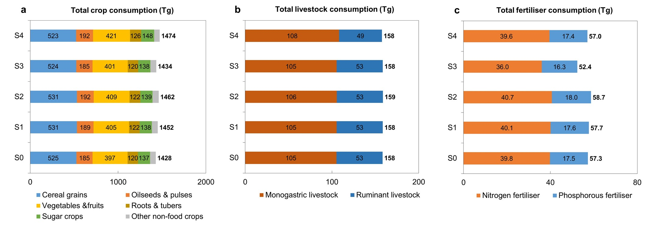

## Supplementary Fig. 1 | Total (a) crop, (b) livestock, and (c) fertiliser consumption (Tg) in scenarios. Total crop consumption exclude food waste and food processing by-products used by “food waste recycling service” and “food waste collection service” sectors (see Supplementary Table 4 for detailed data). Total crop consumption includes crop used for intermediate use (i.e, feeding crops, compound feed, food by-products, processed food) and direct consumption (i.e., primary fresh food).

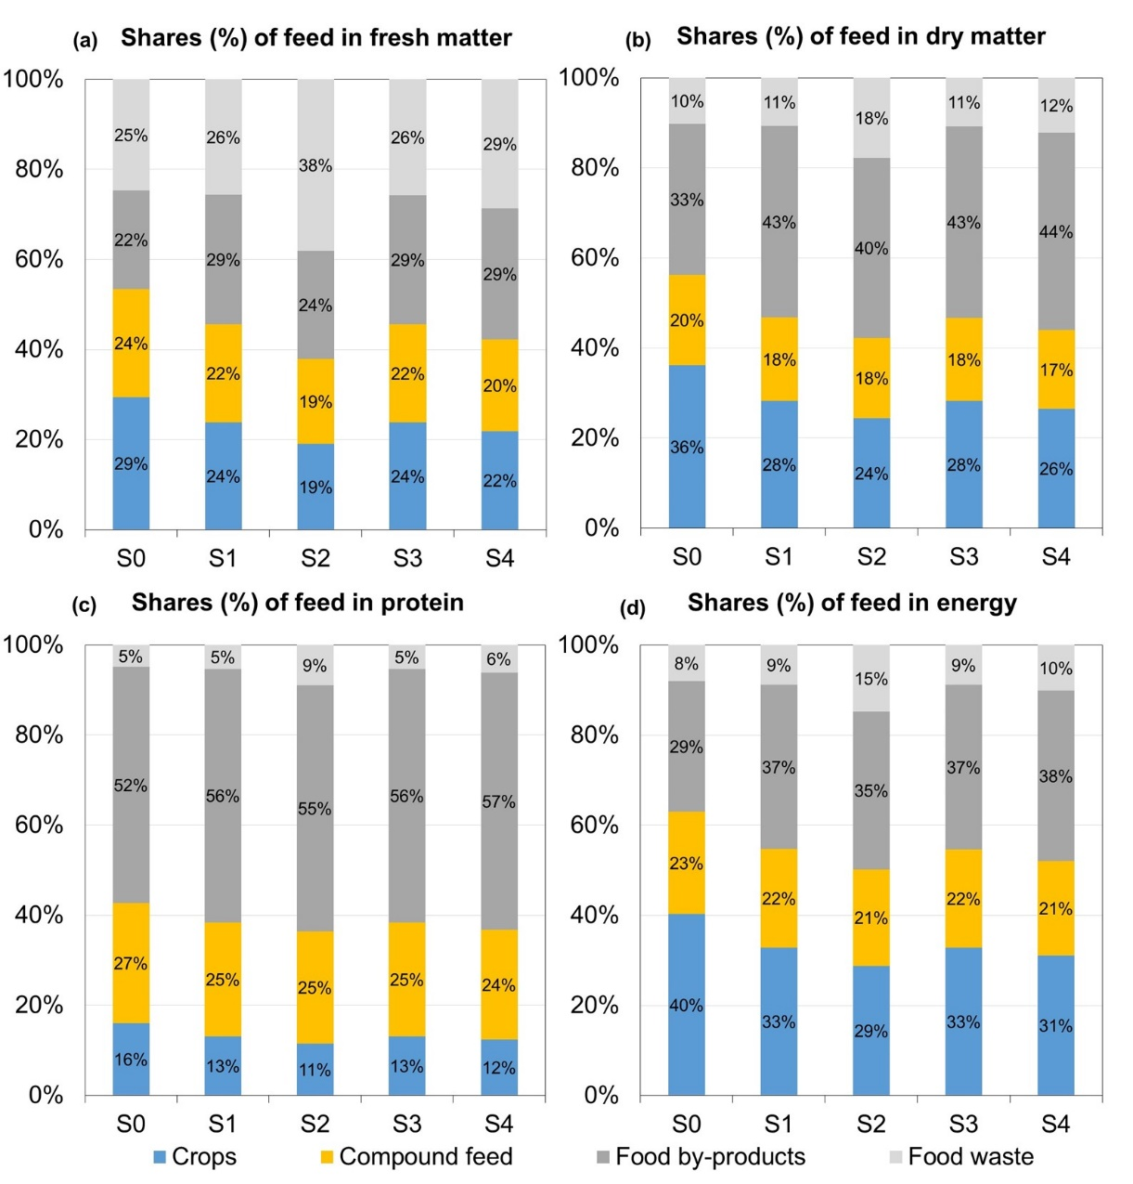

## Supplementary Fig. 2 | Shares (%) of each type of feed within the total feed use for monogastric livestock production, categorized by (a) fresh matter, (b) dry matter, (c) protein, and (d) energy in China in scenarios.

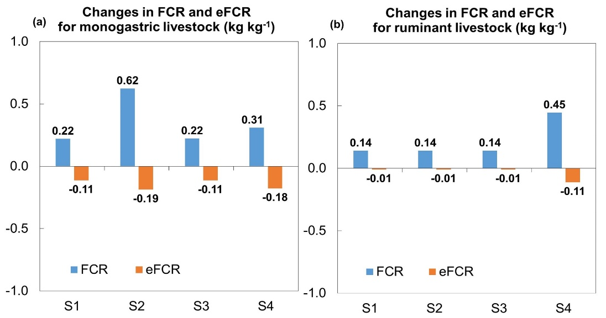

## Supplementary Fig. 3 | Changes in FCR (kg kg-1) and eFCR (kg kg-1) for (a) monogastric livestock and (b) ruminant livestock production in China in scenarios with respect to the baseline (S0).

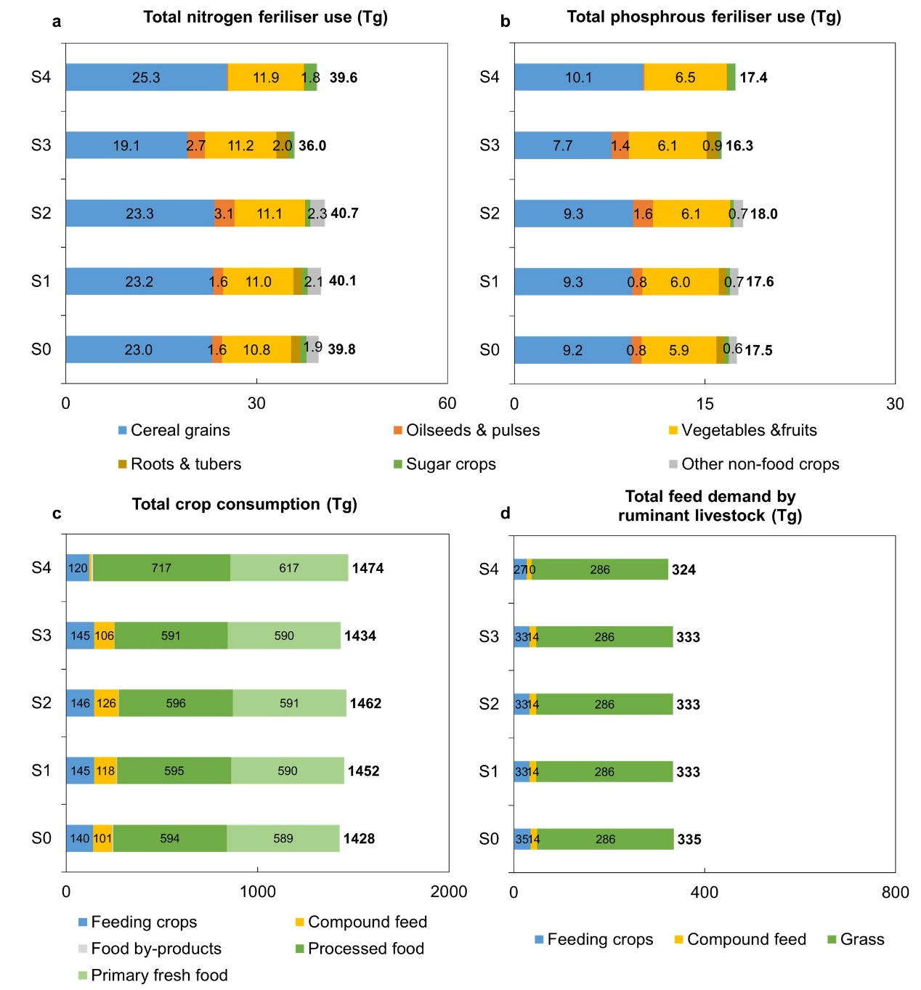

## Supplementary Fig. 4 | (a) Total nitrogen fertiliser use (Tg), (b) phosphorous fertiliser use (Tg), (c) crop consumption (Tg), and (d) feed demand by ruminant livestock (Tg) in scenarios..

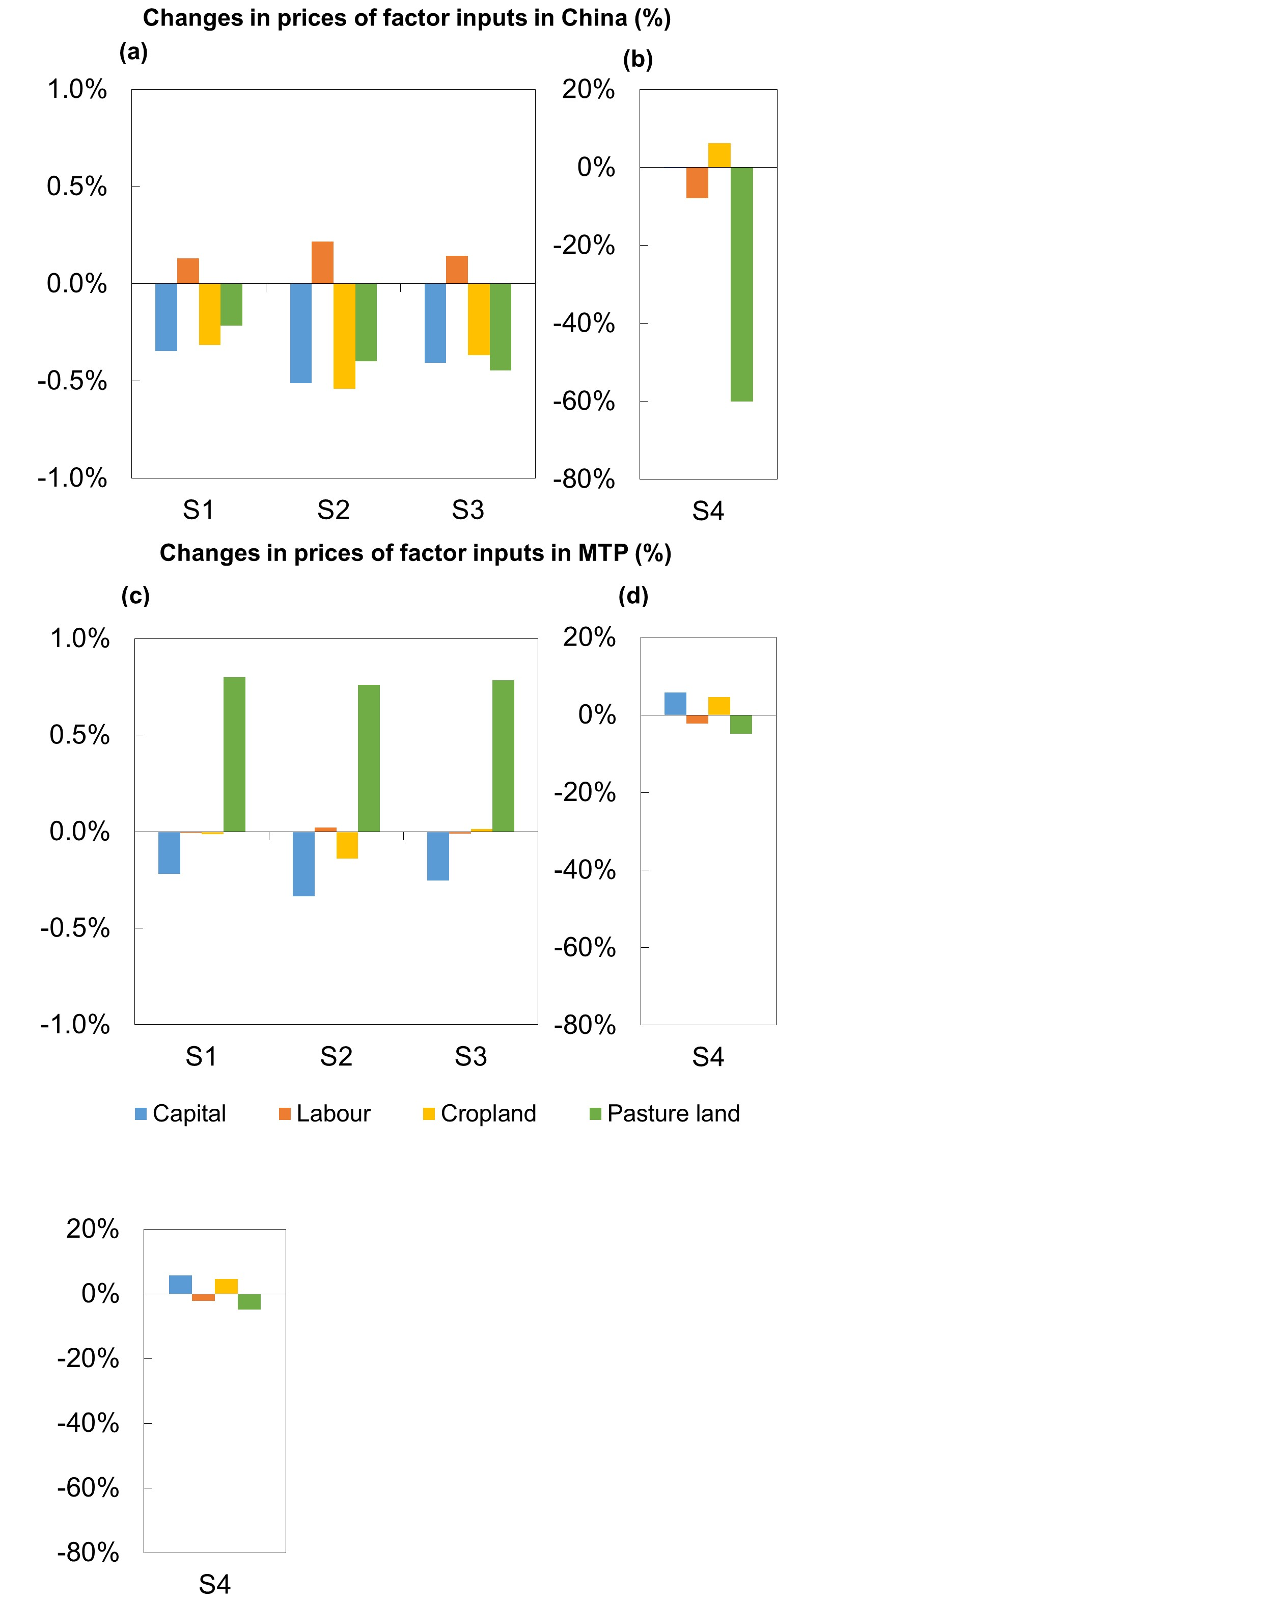

## Supplementary Fig. 5 | Changes (%) in prices of factor inputs in China in scenarios (a) S1-3 and (b) S4 with respect to the baseline (S0). Changes (%) in prices of factor inputs in MTP in scenarios (c) S1-3 and (d) S4 with respect to the baseline (S0).

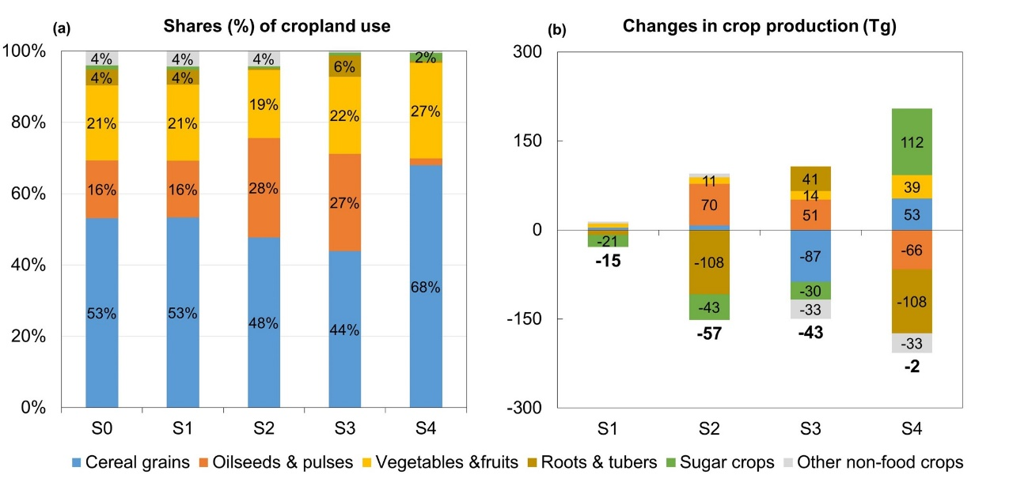

## Supplementary Fig. 6 | (a) Shares (%) of each type of crop within the total cropland use in China in scenarios. (b) Changes (Tg) in crop production in China in scenarios with respect to the baseline (S0).

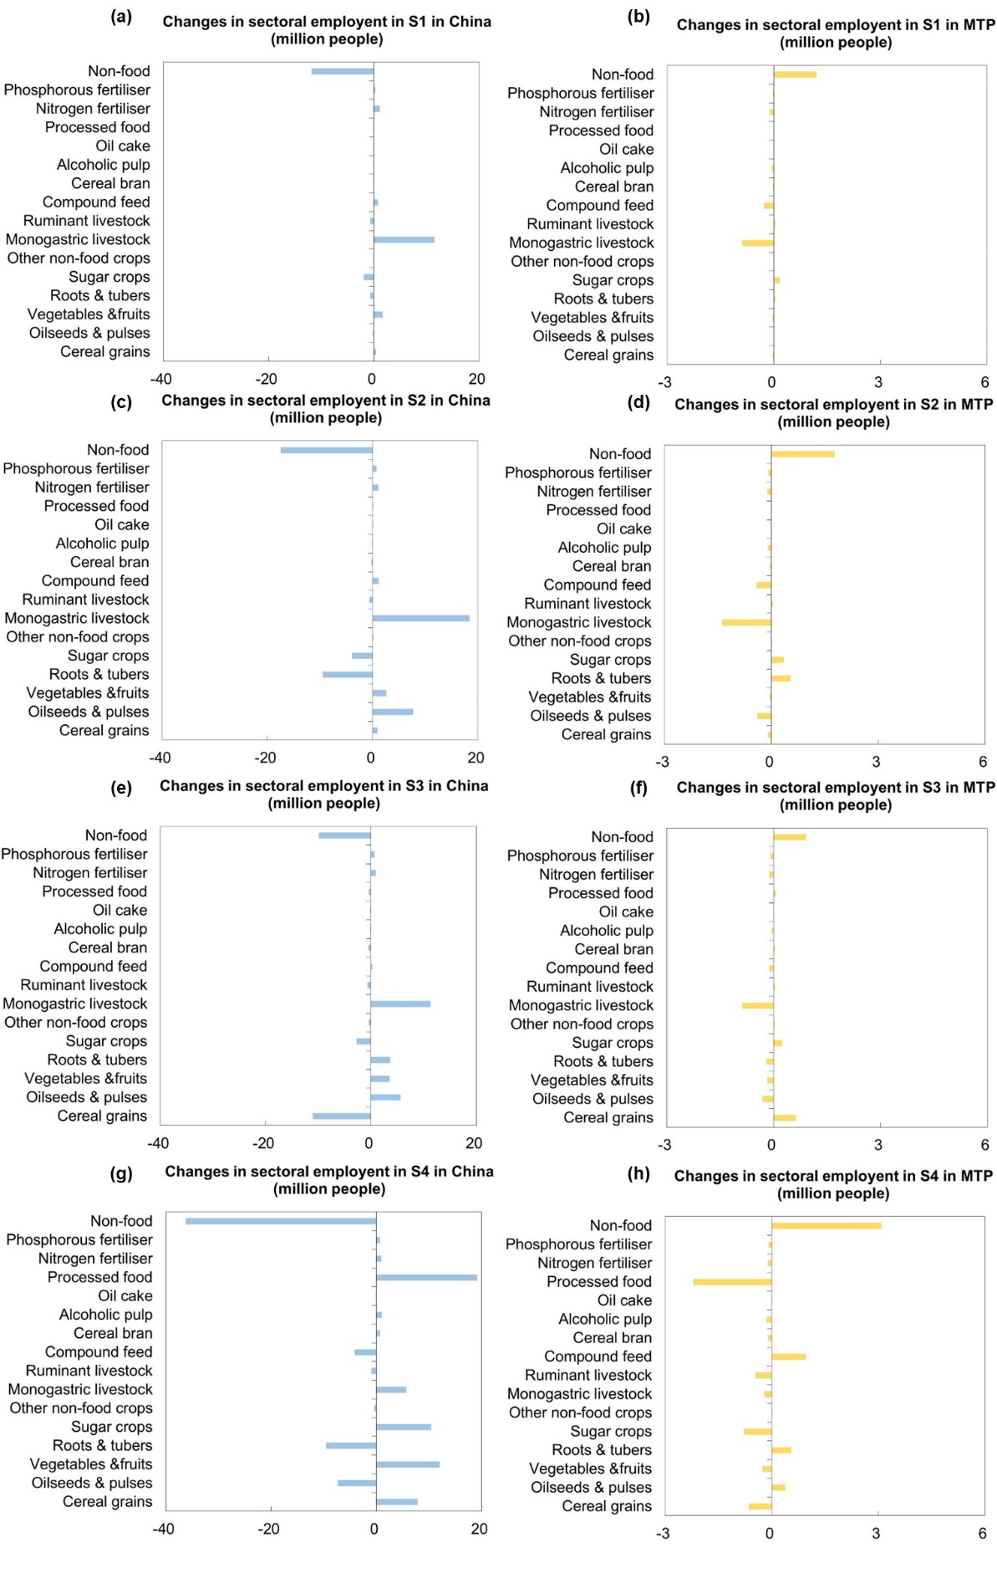

## Supplementary Fig. 7 | Changes (million people) in sectoral employment in China in scenarios (a) S1, (c) S2, (e) S3, and (g) S4 with respect to the baseline (S0). Changes (million people) in sectoral employment in MTP in scenarios (b) S1, (d) S2, (f) S3, and (h) S4 with respect to the baseline (S0).

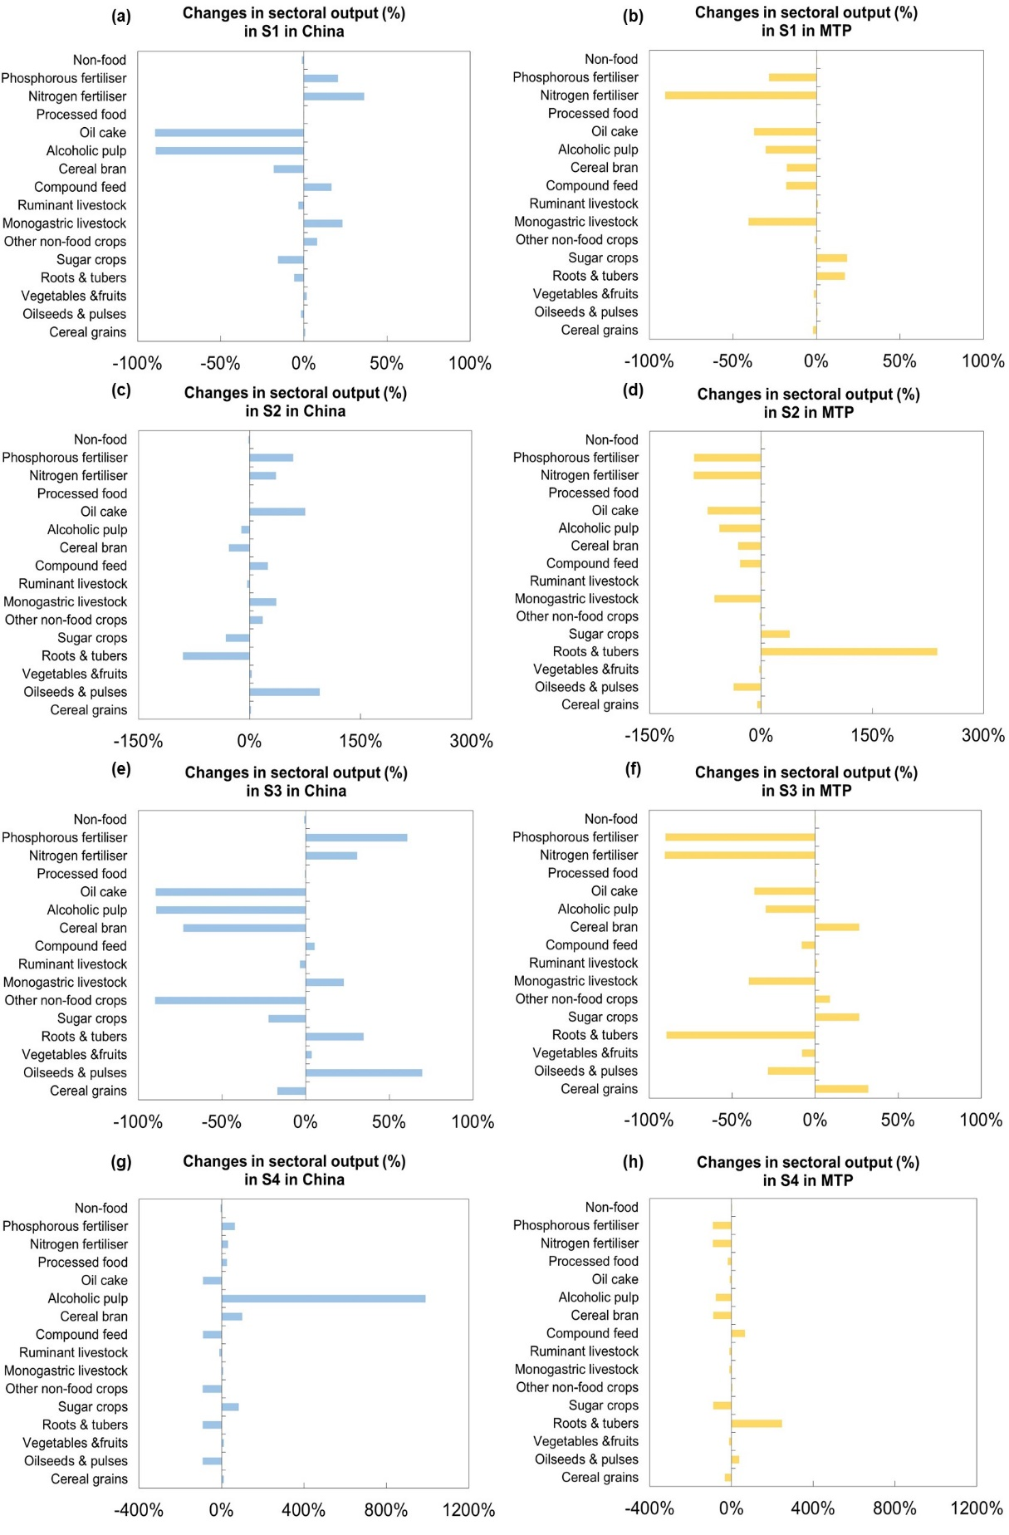

## Supplementary Fig. 8 | Changes (%) in sectoral output (i.e., the value of production) in China in scenarios (a) S1, (c) S2, (e) S3, and (g) S4 with respect to the baseline (S0). Changes (%) in sectoral output (i.e., the value of production) in MTP in scenarios (b) S1, (d) S2, (f) S3, and (h) S4 with respect to the baseline (S0).

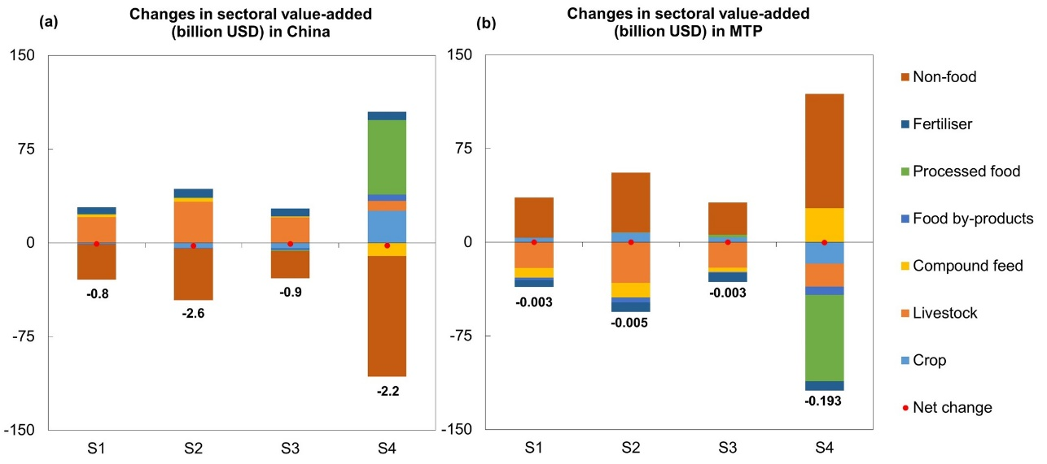

## Supplementary Fig. 9 | Changes (billion USD) in sectoral value-added (a) in China and (b) MTP in scenarios with respect to the baseline (S0).

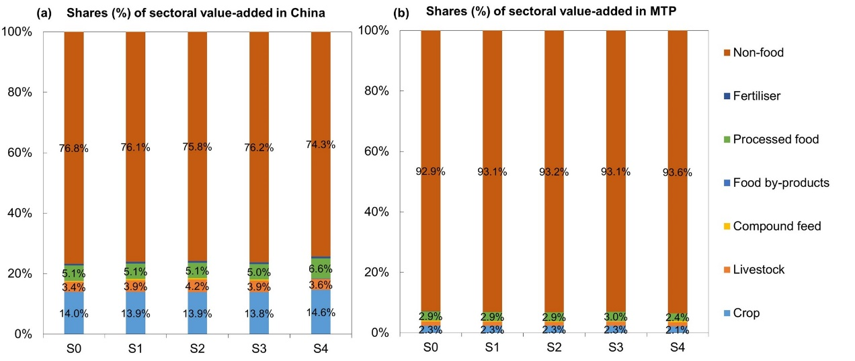

## Supplementary Fig. 10 | Shares (%) of sectoral value-added in (a) China and (b) MTP in scenarios.

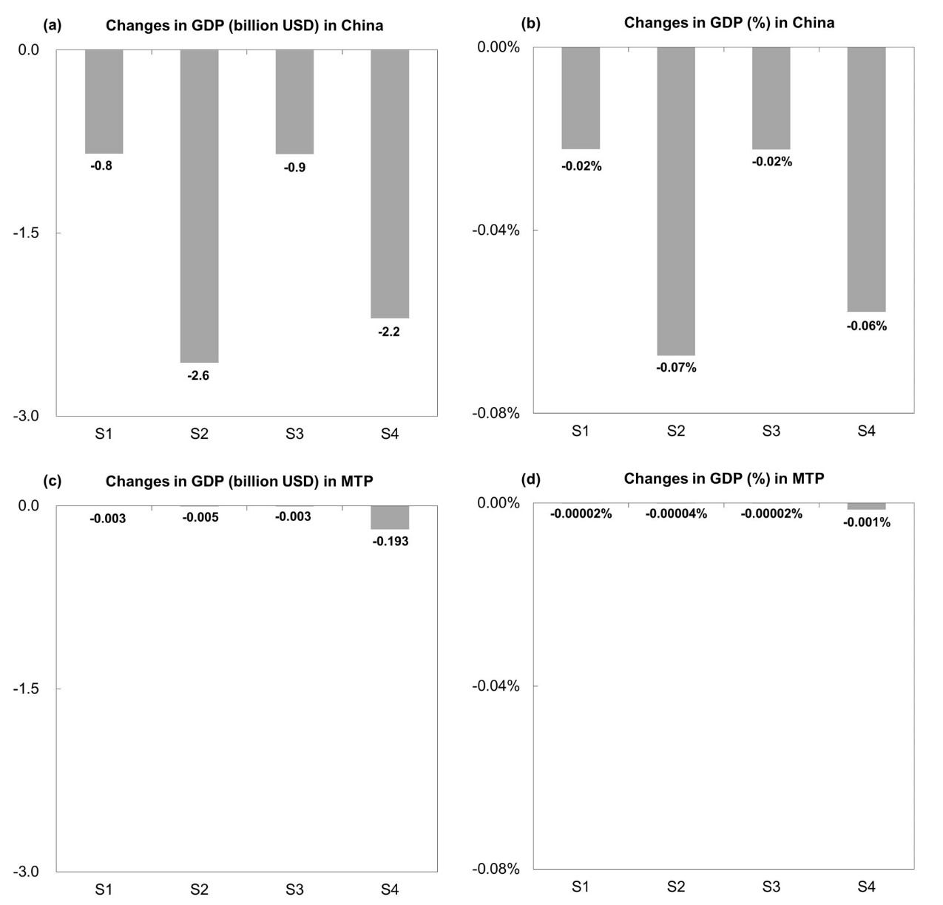

## Supplementary Fig. 11 | (a) Absolute changes (billion USD) and (b) relative changes (%) in GDP in China in scenarios with respect to the baseline (S0). (c) Absolute changes (billion USD) and (d) relative changes (%) in GDP in MTP in scenarios with respect to the baseline (S0).

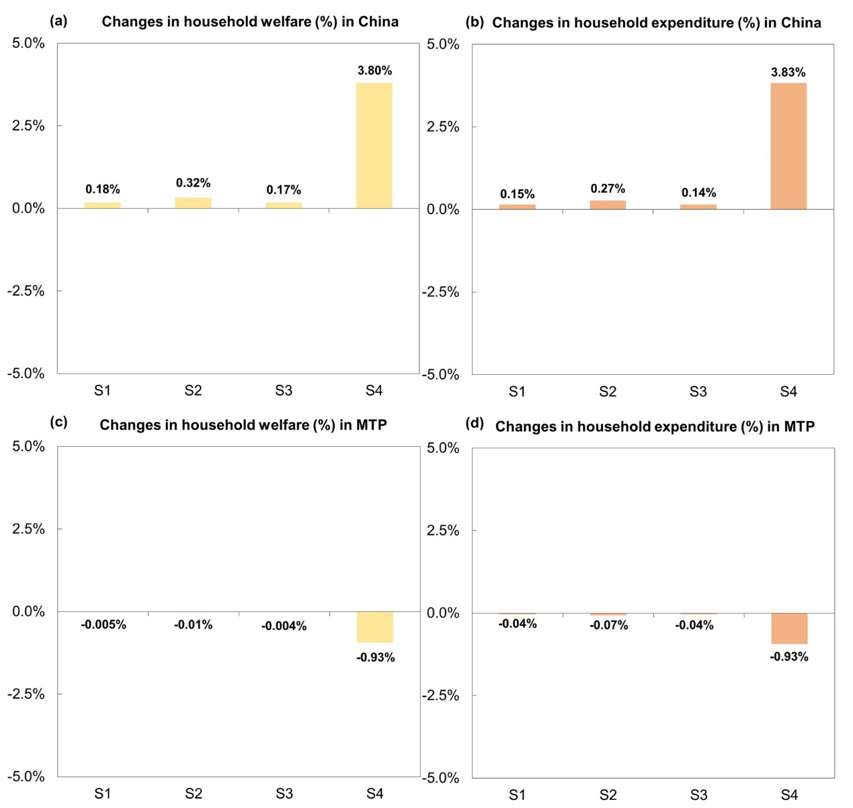

## Supplementary Fig. 12 | Changes (%) in (a) household welfare and (b) household expenditure in China in scenarios with respect to the baseline (S0). Changes (%) in (c) household welfare and (d) household expenditure in MTP in scenarios with respect to the baseline (S0).

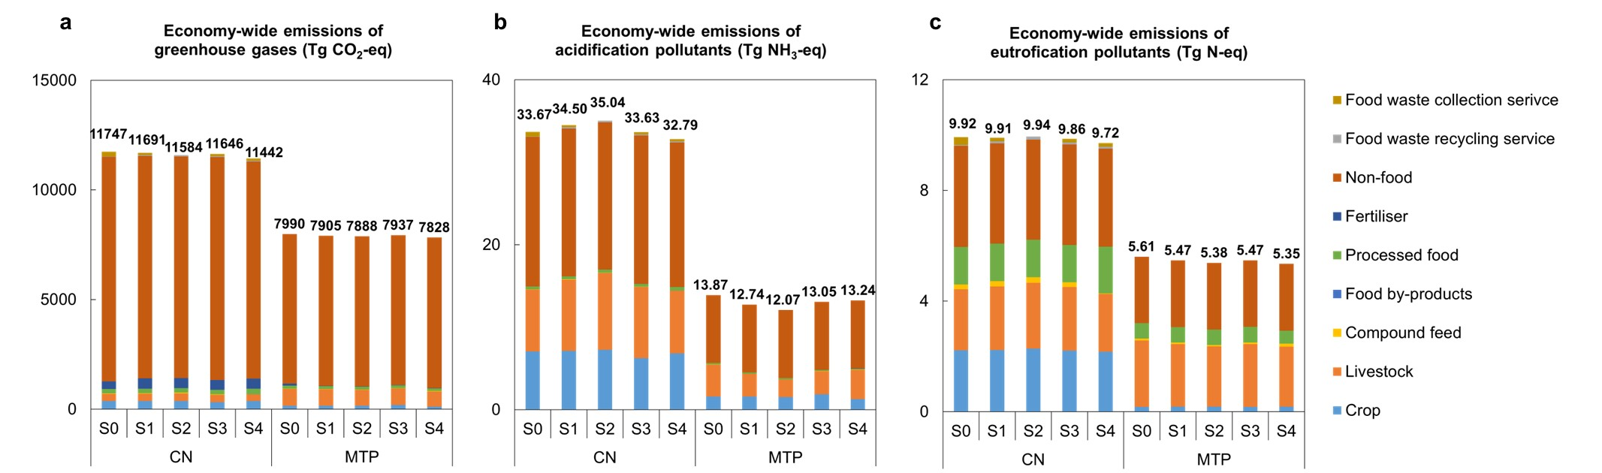

## Supplementary Fig. 13 | (a) Economy-wide emissions of greenhouse gases (Tg CO2-eq), (b) acidification pollutants (Tg NH3-eq), and (c) eutrophication pollutants (Tg N-eq) in China and MTP in scenarios.

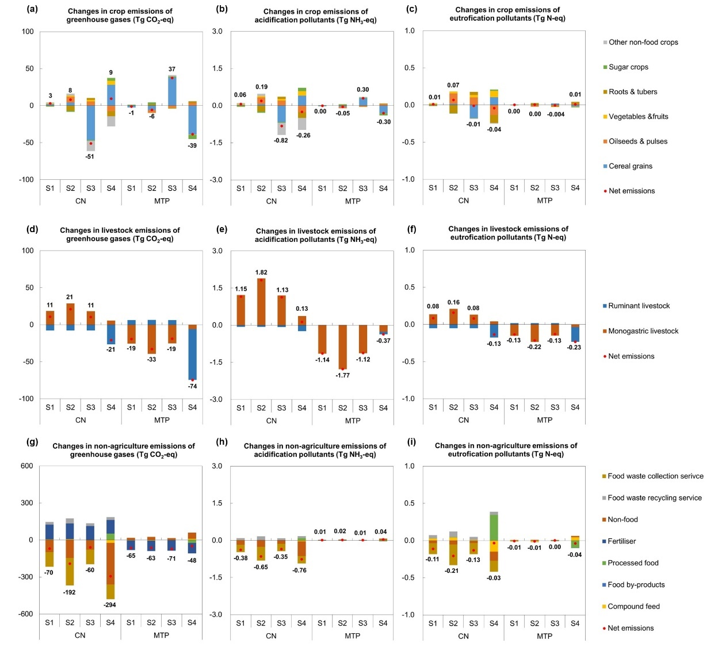

## Supplementary Fig. 14 | Changes in crop emissions of (a) greenhouse gases (Tg CO2-eq), (b) acidification pollutants (Tg NH3-eq), and (c) eutrophication pollutants (Tg N-eq) in China and MTP in scenarios with respect to the baseline (S0). Changes in livestock emissions of (d) greenhouse gases (Tg CO2-eq), (e) acidification pollutants (Tg NH3-eq), and (f) eutrophication pollutants (Tg N-eq) in China and MTP in scenarios with respect to the baseline (S0). Changes in non-agriculture emissions of (g) greenhouse gases (Tg CO2-eq), (h) acidification pollutants (Tg NH3-eq), and (i) eutrophication pollutants (Tg N-eq) in China and MTP in scenarios with respect to the baseline (S0).

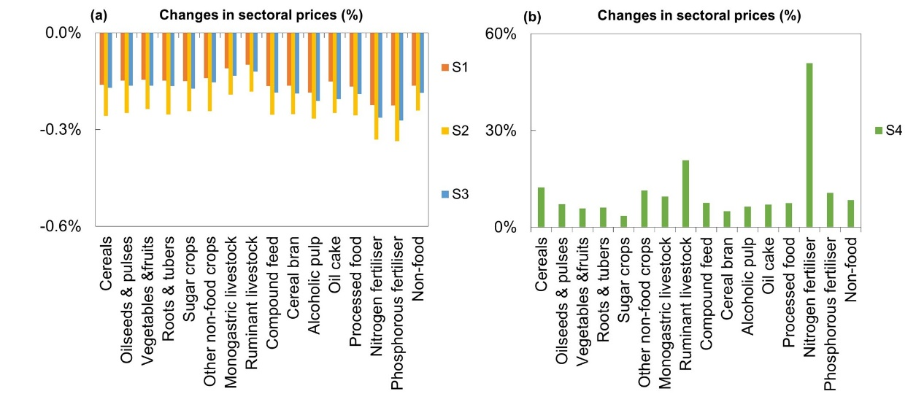

## Supplementary Fig. 15 | Changes (%) in sectoral prices in scenarios (a) S1-S3 and (b) S4 with respect to the baseline (S0).

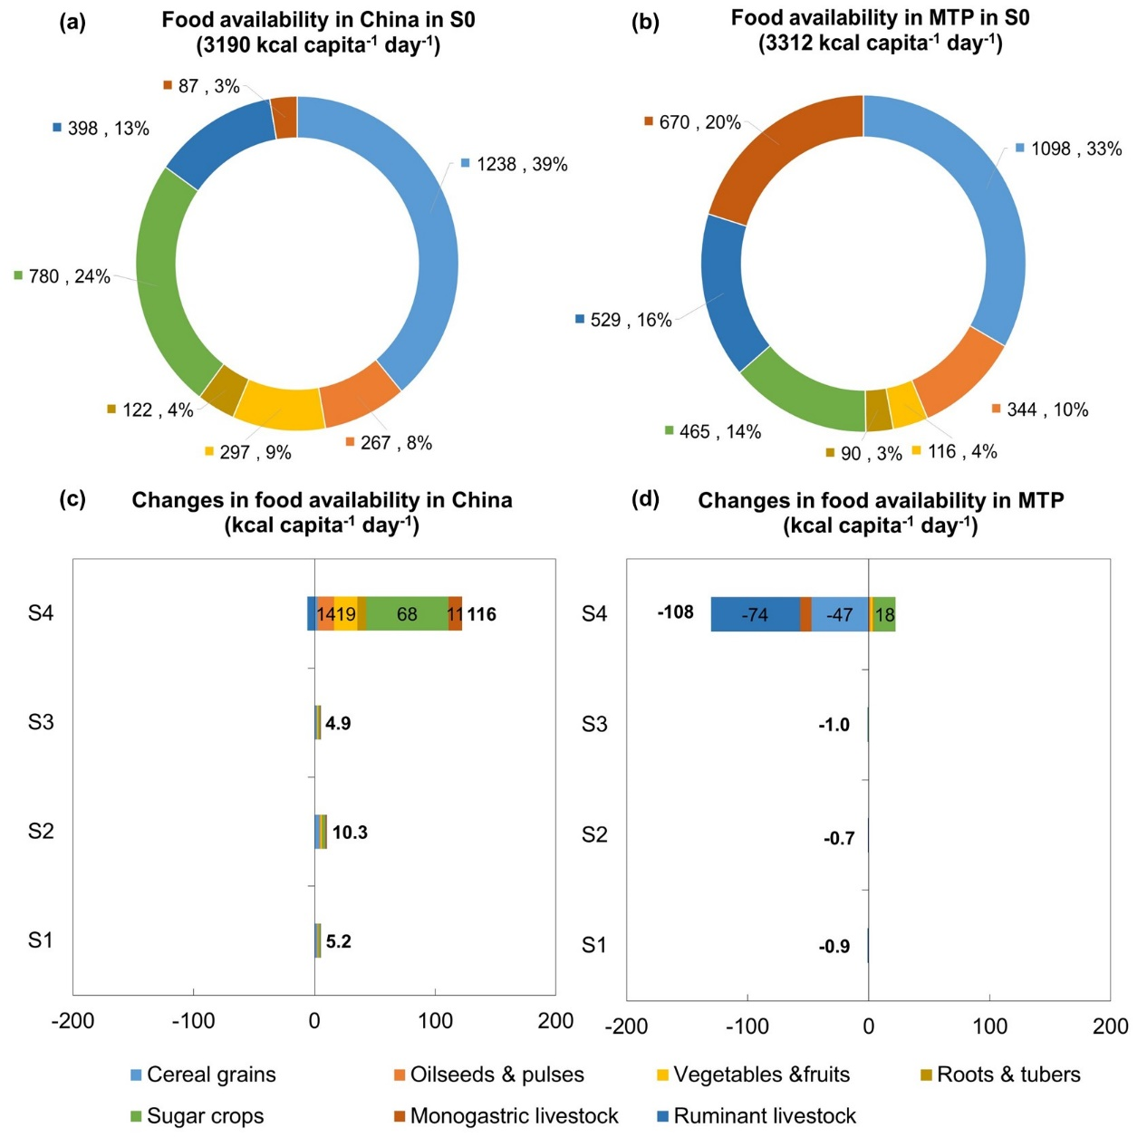

## Supplementary Fig. 16 | Composition of food availability (%; kcal capita-1 day-1) in (a) China and (b) MTP in the baseline (S0). Changes in food availability (kcal capita-1 day-1) in (c) China and (d) MTP in scenarios with respect to the baseline (S0).

# Supplementary Tables

## Supplementary Table 1 | Summary of key assumptions used in scenario narratives and compensatory measures in China.

|  |  |  |
| --- | --- | --- |
| **Scenarios a** | **Food waste used as animal feed in its total supply b** | **Emission mitigation target** |
| **S0: Baseline** | Food waste: 39%  By-products: 51% | No |
| **S1: Partial use of food waste as feed c** | Food waste: 54%  By-products: 100% | No |
| **S2: Full use of food waste as feed c** | Food waste: 100%  By-products: 100% | No |
| **S3: S1 + A modest** **emission mitigation target d** | Food waste: 54%  By-products: 100% | Implementing economy-wide emission taxes to control emissions of greenhouse gases, acidification pollutants, and eutrophication pollutants in both China and its main food and feed trading partners (MTP, including Brazil, the United States, and Canada) no more than their baseline (S0) levels. |
| **S4: S1 + An ambitious emission mitigation target d** | Food waste: 54%  By-products: 100% | Implementing economy-wide emission taxes to reduce emissions of greenhouse gases by 2.6% in China and 2.0% in MTP in line with their annual mitigation target of Intended Nationally Determined Contributions (INDC) under the Paris Agreement 9,10. Implementing economy-wide emission taxes to reduce emissions of acidification and eutrophication pollutants in China by 2.5% and 2.0%, respectively, according to the annual mitigation target set by China’s “14th Five-Year Plan” 11. Implementing economy-wide emission taxes to control emissions of acidification and eutrophication pollutants in MTP no more than the baseline (S0) level. |

a When substituting primary feed (i.e., feeding crops and compound feed) in animal diets with food waste and food processing by-products, we kept the total protein and total energy supplies for per unit of animal output were kept constant in all scenarios.

b In S1, cross-provincial transportation of food waste with high moisture content was not allowed, which limits the maximum utilisation rate of food waste to 54% in China, according to Fang, et al. 7, whereas it was allowed in S2.

c The cost of increasing the supply of food waste recycling service is modelled as a rising percentage of the initial cost of recycling food waste and food processing by-products as feed (54 dollar ton-1), while the cost of decreasing the supply of food waste collection service is modelled as a declining percentage of the initial cost of collecting food waste and food processing by-products for landfill and incineration (82 dollar ton-1). Economies of scale in food waste recycling were considered in S2, where a 1% increase in recycled waste resulted in only a 0.078% rise in recycling costs, indicating that increasing the amount of recycled waste might not necessarily incur additional costs, as reported by Cialani and Mortazavi 8. This is because, initially, recycling entails high fixed costs, yet as production scales up, marginal costs decrease and then stabilise. The total amounts of food waste and food processing by-products and their current use as animal feed and discarded biomass (i.e., landfill and incineration) for China in S0 were presented in Supplementary Tables 3. Physical quantities and prices of food waste recycling service and food waste collection service in China were presented in Supplementary Tables 4-5.

d The main environmental problem associated with food systems depends on emissions from economic activities. Therefore, the introduction of economy-wide emission taxes could subsequently influence the way food is produced, inducing a shift away from emission-intensive production to cleaner alternatives. These policies aim to reduce emissions by pricing environmental emissions. Shadow prices of emissions, derived from the marginal value of the emission balance equations, ensure that total emissions by all producers remain below a specified emission threshold. For a given emission mitigation target for each type of pollutant, the AGE model can endogenously calculate the shadow prices of emissions of various pollutants.

## Supplementary Table 2 | Physical quantities (Tg) in fresh form for each product in China (CN) and its main food and feed trading partners (MTP) in S0.

|  |  |  |
| --- | --- | --- |
|  | CN | MTP |
| Cereal grains a | 521.33 | 595.93 |
| Oilseeds & pulses a | 74.04 | 255.65 |
| Vegetables & fruits a | 397.23 | 116.39 |
| Roots & tubers a | 119.82 | 54.76 |
| Sugar crops a | 133.61 | 792.67 |
| Other non-food crops a | 36.48 | 23.24 |
| Monogastric livestock a | 103.15 | 18.65 |
| Ruminant livestock a | 52.53 | 46.28 |
| Compound feed b | 102.60 | 103.00 |
| Cereal bran c | 31.05 | 12.01 |
| Alcoholic pulp c | 45.60 | 76.09 |
| Oil cake c | 86.42 | 84.02 |
| Processed food d | 593.20 | 580.80 |
| Nitrogen fertiliser | 39.60 | 13.65 |
| Phosphorous fertiliser | 17.43 | 3.13 |
| Grass e | 286.22 | 0.00 |

a Physical quantities ofcereal grains, oilseeds & pulses, vegetables & fruits, roots & tubers, sugar crops, other non-food crops, monogastric livestock, ruminant livestock, nitrogen fertiliser, and phosphorous fertiliser were obtained from FAO 19. Here, physical quantities of cereal grains waste, oilseeds & pulses waste, vegetables & fruits waste, and roots & tubers waste were excluded and presented in Supplementary Table 3.

b Compound feed production data was calculated according to the weighted averages of crops included in the compound feed at the national level.

c Physical quantities of cereal bran, alcoholic pulp, and oil cake were estimated from the consumption of corresponding food products and specific technical conversion factors 20.

d Processed food was calculated according to the weighted averages of crops included in the processed food at the national level.

e Grass from natural grassland was derived from Miao and Zhang 21. Here, grass refers to grass from natural grassland where ruminant livestock is grazing for feed, and grass from remaining grassland is excluded. We do not present grass production data in MTP due to data unavailability.

## Supplementary Table 3 | Utilisation rates (%) of food waste and food processing by-products in the baseline (S0) for China.

|  |  |  |
| --- | --- | --- |
|  | Used as feed (%) | Discarded biomass (%) c |
| Cereals waste | 39% a | Landfill (40%) & incineration (21%) |
| Vegetables & fruits waste | 39% a | Landfill (40%) & incineration (21%) |
| Roots & tubers waste | 39% a | Landfill (40%) & incineration (21%) |
| Oil seeds & pulses waste | 39% a | Landfill (40%) & incineration (21%) |
| Cereal bran | 36% b | Landfill (42%) & incineration (22%) |
| Alcoholic pulp | 16% b | Landfill (55%) & incineration (29%) |
| Oil cake | 72% b | Landfill (18%) & incineration (10%) |

a In China, quantitative empirical data on food waste recycled as feed for monogastric livestock was not available. We infer that the practices of feeding food waste to monogastric livestock in Japan and South Korea are rather similar to those in China, following Fang, et al. 7. Thus, we assumed that a similar proportion (39%, the mean of values in Japan and South Korea 22) of food waste was being used as feed in China in 2014 in S0.

b The utilisation rates of food processing by-products recycled as feed in China in 2014 in S0 were based on Fang, et al. 7.

c Excluding the portion of food waste and food processing by-products recycled as feed, 66% of the remaining amount in China in 2014 was sent to landfills, while 34% was incinerated, according to Kaza, et al. 23 and Bhada-Tata and Hoornweg 24.

## Supplementary Table 4 | Physical quantities (Tg) of food waste and food processing by-products and their utilisation in China in S0.

|  |  |  |  |  |  |  |
| --- | --- | --- | --- | --- | --- | --- |
|  | Total in  fresh form (Tg) | Total in  dry matter (Tg) | Total in crude protein (Tg) | Total in energy (billion MJ) | Physical quantity in fresh form (Tg) | |
|  | Used as feed a | Discarded biomass b |
| **Total food waste** | **226** | **54** | **7** | **690** | **88** | **138** |
| 1) Cereal grains waste b | 36.09 | 31.40 | 3.14 | 447 | 14.08 | 22.02 |
| 2) Vegetables & fruits waste b | 175.01 | 17.50 | 2.98 | 183 | 67.76 | 107.25 |
| 3) Roots & tubers waste b | 13.32 | 3.46 | 0.28 | 42 | 5.20 | 8.13 |
| 4) Oilseeds & pulses waste b | 1.28 | 1.19 | 0.18 | 18 | 0.50 | 0.78 |
| **Total food processing by-products** | **163** | **139** | **49** | **1907** | **78** | **85** |
| 1) Cereal bran c | 31.05 | 27.63 | 4.42 | 338 | 11.08 | 19.97 |
| 2) Alcoholic pulp c | 45.60 | 34.20 | 9.23 | 439 | 6.66 | 38.94 |
| 3) Oil cake c | 86.42 | 76.91 | 35.38 | 1130 | 59.80 | 26.59 |
| **Total** | **389** | **192** | **56** | **2597** | **166** | **223** |

a The amount of food waste used as feed corresponds to the quantity directed to the “food waste recycling service” sector. The amount of food processing by-products used as feed are not directed to the “food waste recycling service” sector; instead, these by-products with economically values are purchased directly by livestock producers in the feed market. When upcycling the discarded biomass of food waste and food processing by-products, these biomass are directed to the “food waste recycling service” sector.

b Discarded biomass of food waste and food processing by-products refers to the quantity collected for landfill and incineration, meaning the amount directed to the “food waste collection service” sector.

## Supplementary Table 5 | Prices of food waste recycling service and food waste collection service in China. a

|  |  |  |  |
| --- | --- | --- | --- |
|  | Food waste treatment | Price b  (dollar ton-1) | Weighted price c  (dollar ton-1) |
| Food waste recycling service | Recycling waste as feed | 54 | 54 |
|  | Collection | 40 |  |
| Food waste collection service | Landfill | 31 | 82 |
|  | Incineration | 64 |  |

a Food waste recycling service refers to recycling food waste as feed for monogastric livestock production, and food waste collection service means collecting food waste for landfill and incineration.

b The process of recycling food waste and food processing by-products as animal feed involves sorting, shredding, thermal treatment, fermentation, hydrolysis, and extrusion to create animal feed, as outlined by Alsaleh and Aleisa 25. Collection includes pick up, transfer, and transport to final disposal site for food waste. By multiplying the quantity of food waste with the price of food waste treatment, we can calculate the value of food waste generation. The prices of food waste recycling service and food waste collection service are obtained from Alsaleh and Aleisa 25, Kaza, et al. 23 and Bhada-Tata and Hoornweg 24. Since the value of food waste generation needs to be taken from the “wtr” demand of consumers and monogastric producers, we further checked whether or not the value of food waste generation is more than 80% of the initial demand of “wtr”. If it is higher than 80% of the “wtr” demand, the value of food waste generation is scaled down.

c The weighted price of food waste collection service = collection price (40 $/t) + 66%*landfill price (31$/t)+34%*incineration price (64$/t)=82$/t.

## Supplementary Table 6 | The economic and mass allocation of food processing main and by-products. a

|  |  |  |  |  |
| --- | --- | --- | --- | --- |
|  | Main and by-products | By-product  group | Economic  share (%) | Mass  share (%) |
| Cereal flour production a | Cereal flour | - | 93% | 86% |
|  | Cereal bran | Cereal bran | 7% | 14% |
| Maize ethanol production b | Maize ethanol | - | 83% | 49% |
|  | Distillers' grain from maize ethanol | Alcoholic pulp | 17% | 51% |
| Barley beer production b | Barley beer | - | 98% | 82% |
|  | Brewers' grain from barley beer | Alcoholic pulp | 2% | 18% |
| Liquor production b | Liquor | - | 97% | 25% |
|  | Distillers' grain from liquor | Alcoholic pulp | 3% | 75% |
| Vegetable oil production c | Soybean oil | - | 44% | 23% |
|  | Soybean oil cake | Oil cake | 56% | 77% |
|  | Other oil | - | 66% | 43% |
|  | Other oil cake | Oil cake | 34% | 57% |

a Data source: Haque, et al. 26, Mackenzie, et al. 27, Nyhan, et al. 28, and Pourmehdi and Kheiralipour 29

## Supplementary Table 7 | Estimated mean dry matter (DM, %), crude protein (CP, %), and energy (MJ kg DM-)contents of feed sub-groups in China (CN) and its main food and feed trading partners (MTP). a

|  |  |  |  |  |  |  |
| --- | --- | --- | --- | --- | --- | --- |
|  | Dry matter (DM, %) | | Crude protein (CP, %) | | Energy (MJ kg DM-1) | |
|  | CN | MTP | CN | MTP | CN | MTP |
| Cereal grains | 89 | 89 | 11 | 10 | 18.25 | 18.82 |
| Oilseeds &pulses | 74 | 86 | 22 | 32 | 19.72 | 19.78 |
| Vegetables &fruits | 10 | 10 | 19 | 19 | 13.80 | 13.80 |
| Roots &tubers | 29 | 29 | 5 | 5 | 21.54 | 21.54 |
| Sugar crops | 69 | 69 | 16 | 16 | 19.68 | 19.68 |
| Compound feed | 48 | 70 | 34 | 23 | 18.61 | 19.36 |
| Cereal bran | 89 | 89 | 16 | 16 | 12.24 | 12.24 |
| Alcoholic pulp | 75 | 75 | 27 | 27 | 12.84 | 12.84 |
| Oil cake | 89 | 89 | 46 | 47 | 14.69 | 14.94 |
| Cereal grains waste | 87 | - | 10 | - | 14.25 | - |
| Vegetables & fruits waste | 10 | - | 17 | - | 10.45 | - |
| Roots & tubers waste | 26 | - | 8 | - | 12.15 | - |
| Oilseeds & pulses waste | 94 | - | 15 | - | 14.70 | - |
| Cereal bran waste | 89 | - | 16 | - | 12.24 | - |
| Alcoholic pulp waste | 75 | - | 27 | - | 12.84 | - |
| Oil cake waste | 89 | - | 46 | - | 14.69 | - |
| Grass | 27 | 27 | 12 | 12 | 11.20 | 11.20 |

a The values were weighted averages of feed types included in the groups at the national level. Data were sourced from the NUFER database 30, MITERRA-EUROPE database 31, NRC 32, NRC 33, NRC 34, NRC 35, and China Feed–database Information Network Centre ((<http://www.chinafeeddata.org.cn/>).

# Supplementary References

1 Ginsburgh, V. & Keyzer, M. A. *The Structure of Applied General Equilibrium Models*. (The MIT Press, 2002).

2 Zhu, X. & Van Ierland, E. The enlargement of the European Union: Effects on trade and emissions of greenhouse gases. *Ecological Economics* **57**, 1-14 (2006). <https://doi.org/https://dx.doi.org/10.1016/j.ecolecon.2005.03.030>

3 Goedkoop, M. *et al.* ReCiPe 2008: A life cycle impact assessment method which comprises harmonised category indicators at the midpoint and the endpoint level. 1-126 (2009).

4 Deardorff, A. V. The general validity of the Heckscher-Ohlin theorem. *The American Economic Review* **72**, 683-694 (1982).

5 McLure Jr, C. E. General equilibrium incidence analysis: The Harberger model after ten years. *Journal of Public Economics* **4**, 125-161 (1975).

6 Shoven, J. B. & Whalley, J. *Applying general equilibrium*. (Cambridge university press, 1992).

7 Fang, Q. *et al.* Low-opportunity-cost feed can reduce land-use-related environmental impacts by about one-third in China. *Nature Food* (2023). <https://doi.org/10.1038/s43016-023-00813-x>

8 Cialani, C. & Mortazavi, R. The Cost of Urban Waste Management: An Empirical Analysis of Recycling Patterns in Italy. *Frontiers in Sustainable Cities* **2** (2020). <https://doi.org/10.3389/frsc.2020.00008>

9 IPCC-WGIII. Summary for policymakers (AR5). (2014).

10 UNFCC. Paris agreement. (2015).

11 State Council of the People's Republic of China. *Notice of the State Council on Issuing the Comprehensive Work Plan for Energy Conservation and Emission Reduction during the 14th Five-Year Plan*, <<https://www.gov.cn/xinwen/2022-01/24/content_5670214.htm>> (2022).

12 Woltjer, G. B. *et al.* The MAGNET model: Module description. (LEI Wageningen UR, LEI Wageningen UR, 2014).

13 Lee, H.-L. The GTAP Land Use Data Base and the GTAPE-AEZ Model: incorporating agro-ecologically zoned land use data and land-based greenhouse gases emissions into the GTAP Framework. (2005).

14 Van Zanten, H. H. E. *et al.* Defining a land boundary for sustainable livestock consumption. *Global Change Biology* **24**, 4185-4194 (2018). <https://doi.org/10.1111/gcb.14321>

15 Sandström, V. *et al.* Food system by-products upcycled in livestock and aquaculture feeds can increase global food supply. *Nature Food* **3**, 729-740 (2022). <https://doi.org/10.1038/s43016-022-00589-6>

16 van Hal, O. *et al.* Upcycling food leftovers and grass resources through livestock: Impact of livestock system and productivity. *Journal of Cleaner Production* **219**, 485-496 (2019). <https://doi.org/https://doi.org/10.1016/j.jclepro.2019.01.329>

17 UN. *Transforming our world: the 2030 agenda for sustainable development*, <<https://sdgs.un.org/2030agenda>> (2015).

18 Freund, F. & Springmann, M. Policy analysis indicates health-sensitive trade and subsidy reforms are needed in the UK to avoid adverse dietary health impacts post-Brexit. *Nature Food* **2**, 502-508 (2021). <https://doi.org/10.1038/s43016-021-00306-9>

19 FAO. <<http://www.fao.org/faostat/en/#data>> (2022).

20 FAO. Technical Conversion Factors for Agricultural Commodities. (1997).

21 Miao, D. & Zhang, Y. National grassland monitoring report. (2014).

22 Zu Ermgassen, E. K., Phalan, B., Green, R. E. & Balmford, A. Reducing the land use of EU pork production: where there's swill, there's a way. *Food Policy* **58**, 35-48 (2016). <https://doi.org/10.1016/j.foodpol.2015.11.001>

23 Kaza, S., Yao, L., Bhada-Tata, P. & Van Woerden, F. *What a waste 2.0: a global snapshot of solid waste management to 2050*. (World Bank Publications, 2018).

24 Bhada-Tata, P. & Hoornweg, D. A. *What a waste?: a global review of solid waste management*. (World Bank Publications, 2012).

25 Alsaleh, A. & Aleisa, E. Triple Bottom-Line Evaluation of the Production of Animal Feed from Food Waste: A Life Cycle Assessment. *Waste and Biomass Valorization* **14**, 1169-1195 (2023). <https://doi.org/10.1007/s12649-022-01914-7>

26 Haque, M. A., Liu, Z., Demilade, A. & Kumar, N. M. Assessing the Environmental Footprint of Distiller-Dried Grains with Soluble Diet as a Substitute for Standard Corn&ndash;Soybean for Swine Production in the United States of America. *Sustainability* **14**, 1161 (2022).

27 Mackenzie, S. G., Leinonen, I., Ferguson, N. & Kyriazakis, I. Towards a methodology to formulate sustainable diets for livestock: accounting for environmental impact in diet formulation. *British Journal of Nutrition* **115**, 1860-1874 (2016). <https://doi.org/10.1017/S0007114516000763>

28 Nyhan, L., Sahin, A. W., Schmitz, H. H., Siegel, J. B. & Arendt, E. K. Brewers’ Spent Grain: An Unprecedented Opportunity to Develop Sustainable Plant-Based Nutrition Ingredients Addressing Global Malnutrition Challenges. *Journal of Agricultural and Food Chemistry* **71**, 10543-10564 (2023). <https://doi.org/10.1021/acs.jafc.3c02489>

29 Pourmehdi, K. & Kheiralipour, K. Assessing the effects of wheat flour production on the environment. *Advances in Environmental Technology* **6**, 111-117 (2020).

30 Ma, L. *et al.* Modeling nutrient flows in the food chain of China. *J Environ Qual* **39**, 1279-1289 (2010). <https://doi.org/10.2134/jeq2009.0403>

31 Hou, Y. *et al.* Feed use and nitrogen excretion of livestock in EU-27. *Agriculture, Ecosystems & Environment* **218**, 232-244 (2016). <https://doi.org/10.1016/j.agee.2015.11.025>

32 NRC. *Nutrient Requirements of Poultry*. (National Academy Press, 1994).

33 NRC. *Nutrient Requirements of Swine*. (National Academy Press, 1998).

34 NRC. *Nutrient Requirements of Beef Cattle*. (National Academy Press, 2000).

35 NRC. *Requirements of Dairy Cattle*. (National Academy Press, 2001).

36 Sturm, V. in *14th Annual Conference on Global Economic Analysis* (Global Trade Analysis Project, 2011).

37 Bartelings, H., Kavallari, A., van Meijl, H. & Von Lampe, M. in *19th Annual Conference on Global Economic Analysis* (Global Trade Analysis Project, 2016).

38 GTAP. *GTAP version 10 Database*, <<http://www.gtap.agecon.purdue.edu/>> (2014).

39 Ludemann, C. I., Gruere, A., Heffer, P. & Dobermann, A. Global data on fertilizer use by crop and by country. *Scientific Data* **9**, 501 (2022). <https://doi.org/10.1038/s41597-022-01592-z>

40 Climate Analysis Indicators Tool (CAIT). <<https://www.climatewatchdata.org/?source=cait>> (2014).

41 Hong, J., Li, X. & Zhaojie, C. Life cycle assessment of four municipal solid waste management scenarios in China. *Waste Management* **30**, 2362-2369 (2010). <https://doi.org/https://doi.org/10.1016/j.wasman.2010.03.038>

42 Hong, J. *et al.* Intensification of municipal solid waste disposal in China. *Renewable and Sustainable Energy Reviews* **69**, 168-176 (2017). <https://doi.org/https://doi.org/10.1016/j.rser.2016.11.185>

43 Liu, L. *et al.* Exploring global changes in agricultural ammonia emissions and their contribution to nitrogen deposition since 1980. *Proceedings of the National Academy of Sciences* **119**, e2121998119 (2022). <https://doi.org/doi:10.1073/pnas.2121998119>

44 Huang, T. *et al.* Spatial and Temporal Trends in Global Emissions of Nitrogen Oxides from 1960 to 2014. *Environmental Science & Technology* **51**, 7992-8000 (2017). <https://doi.org/10.1021/acs.est.7b02235>

45 Dahiya, S. *et al.* Ranking the World’s Sulfur Dioxide (SO2) Hotspots: 2019–2020. *Delhi Center for Research on Energy and Clean Air-Greenpeace India: Chennai, India* **48** (2020).

46 Hamilton, H. A. *et al.* Trade and the role of non-food commodities for global eutrophication. *Nature Sustainability* **1**, 314-321 (2018).

# Appendix Tables

## Appendix Table 1 | Sectoral aggregation scheme.

| Aggregated sectors | GTAP original sectors |
| --- | --- |
| Cereal grains | “Paddy rice (pdr)”, “Processed rice (pcr)”, “Wheat (wht)”, and “Cereals grains nec (gro)” sectors |
| Oilseeds & pulses | “Oil seeds (osd)” sector, and pulses split from the original “Vegetables& fruits (v_f)” sector |
| Vegetables & fruits | “Vegetables, fruits, nuts (v_f)” sector after splitting out pulses, and roots & tubers |
| Roots &tubers | Split from the original “Vegetables& fruits (v_f)” sector |
| Sugar crops | “Sugar cane & Sugar beet (c_b)” and Sugar (sgr)” sectors |
| Other non-food crops | “Plant-based fibers (pfb)”, and “Crops nec (ocr)” sectors |
| Monogastric livestock | “Animal products nec (oap)” and “Meat products nec (omt)” sectors |
| Ruminant livestock | “Cattle, sheep, goats, horses (ctl)”, “Meat: cattle, sheep, goats, horses (cmt)”, “Raw milk (rmk)”, “Wool, silk-worm cocoons (wol)”, and “Dairy products (mil)” sectors |
| Compound feed a | Split from the original “Food products nec (ofd)” sector |
| Cereal bran a | Split from the original “Food products nec (ofd)” sector |
| Alcoholic pulp a | Distiller’s grains from maize ethanol production split from the original “Food products nec (ofd)” sector; Distiller’s grains from liquor production and brewer’s grains from barley beer production split from the original “Beverages and Tobacco products (b_t)” sector |
| Oil cake a | Split from the original “Vegetable oils and fats (vol)” sector |
| Processed food a | “Food products nec (ofd)” sector after splitting out splitting out compound feed, cereal bran, and distiller's grains from maize ethanol production; “Beverages and Tobacco products (b_t)” sector after splitting out distiller’s grains from liquor production and brewer’s grains from barley beer production; Vegetable oils and fats (vol)” sector after splitting out oil cake |
| Nitrogen fertiliser b | Split from the original “Manufacture of chemicals and chemical products (chm)” sector |
| Phosphorous fertiliser b | Split from the original “Manufacture of chemicals and chemical products (chm)” sector |
| Food waste recycling service c | Split from the original “Waste and water (wtr)” sector |
| Food waste collection service c | Split from the original “Waste and water (wtr)” sector |
| Non-food | “Manufacture of chemicals and chemical products (chm)” sector after splitting out nitrogen fertiliser and phosphorous fertiliser; “Waste and water (wtr)” sector after splitting out food waste recycling service and food waste collection service; “Forestry (frs)”, “Fishing (fsh)”, “Coal (coa)”, “Oil (oil)”, “Gas (gas)”, “Minerals nec (oxt)”, “Petroleum, coal products (p_c)”, “Electricity (ely)”, “Gas manufacture, distribution (gdt)”, “Textiles （tex)”, “Wearing apparel (wap)”, “Leather products (lea)”, “Wood products (lum)”, “Paper products, publishing (ppp)”, “Manufacture of pharmaceuticals, medicinal chemical and botanical products (bph)”, “Manufacture of rubber and plastics products (rpp)”, “Mineral products nec (nmm)”, “Ferrous metal (i_s)”, “Metal nec (nfm)”, “Metal products (fmp)”, Electronic equipment (ele)”, “Manufacture of electrical equipment (eeq)”, “Manufacture of machinery and equipment n.e.c. (ome)”, “Motor vehicles and parts (mvh)”, “Transport equipment nec (otn)”, “Manufactures nec (omf)”, “Construction (cns)”, “Wholesale and retail trade; repair of motor vehicles and motorcycles (trd)”, “Accommodation, Food and service activities (afs)”, “Land transport and transport via pipelines (otp)”, “Warehousing and support activities (whs)”, “Sea transport (wtp)”, “Air transport (atp)”, “Communication (cmn)”, “Financial services nec (ofi)”, “Insurance (ins)”, “Real estate activities (rsa)”, “Other Business Services nec (obs)”, “Recreation & other services (ros)”, “Other Services (Government) (osg)”, “Education (edu)”, “Human health and social work (hht)”, “Dwellings: ownership of dwellings (imputed rents of houses occupied by owners) (dwe)” sectors |

a Compound feed was split from the “Food products nec (ofd)” sector in the original GTAP database. The substance flow from “Food products nec (ofd)” to monogastric livestock and ruminant livestock was compound feed. Cereal bran and distiller’s grains from maize ethanol production were taken from the newly-splitted sector of compound feed according to the shares of economic values of cereal bran and distiller’s grains from maize ethanol production in the total economic value of compound feed. Economic values of cereal bran and distiller’s grains from maize ethanol production were calculated by multiplying the physical quantity (in tons) and the corresponding price (dollar per ton). Distiller’s grains from liquor production and brewer’s grains from barley beer production were split from the “Beverages and Tobacco products (b_t)” sector in the original GTAP database. The substance flow from “Beverages and Tobacco products (b_t)” to monogastric livestock were distillers' grains from liquor production and brewers' grains from barley beer production. Oil cake was split from the “Vegetable oils and fats (vol)” sector in the original GTAP database. The substance flow from the “Vegetable oils and fats (vol)” sector to monogastric livestock was oil cake.

b The nitrogen and phosphorus fertilisers were taken from the original 'Manufacture of chemicals and chemical products' sector following the method of Sturm 36 and Bartelings, et al. 37.

c Food waste recycling service and food waste collection service were split from the “Waste and water (“wtr”) sector in the original GTAP database according to the shares of economic values of food waste recycling service and food waste collection service in the total economic value of “Waste and water (“wtr”) sector. The economic values of food waste recycling service and food waste collection service were calculated by multiplying the physical quantity (in tons) and the corresponding price (dollar per ton). Since the value of food waste generation needs to be taken from the 'wtr' demand of consumers and monogastric producers, we further checked whether or not the value of food waste generation is more than 80% of the initial demand of "wtr". If it is higher than 80% of the 'wtr' demand, the value of food waste generation are scaled down.

## Appendix Table 2 | The social accounting matrix in the base year of 2014 for China (million $).a

|  | cer | osd | vf | rt | sgr | ocr | oap | ctl | cof | bran | pulp | cake | otf | nfe | pfe | nf | CONS | XNET | TOT |
| --- | --- | --- | --- | --- | --- | --- | --- | --- | --- | --- | --- | --- | --- | --- | --- | --- | --- | --- | --- |
| cer | 0 | 0 | 0 | 0 | 0 | 0 | 29229 | 9055 | 11363 | 1372 | 67 | 0 | 81831 | 0 | 0 | 0 | 61825 | -2016 | 192727 |
| osd | 0 | 0 | 0 | 0 | 0 | 0 | 1002 | 230 | 8312 | 0 | 0 | 182 | 42993 | 0 | 0 | 0 | 5092 | -34661 | 23150 |
| vf | 0 | 0 | 0 | 0 | 0 | 0 | 5685 | 1495 | 18959 | 0 | 0 | 0 | 98059 | 0 | 0 | 0 | 145756 | -139 | 269815 |
| rt | 0 | 0 | 0 | 0 | 0 | 0 | 595 | 157 | 1986 | 0 | 0 | 0 | 10270 | 0 | 0 | 0 | 15265 | -15 | 28259 |
| sgr | 0 | 0 | 0 | 0 | 0 | 0 | 192 | 515 | 1280 | 0 | 0 | 0 | 6619 | 0 | 0 | 0 | 24553 | -903 | 32256 |
| ocr | 0 | 0 | 0 | 0 | 0 | 0 | 664 | 262 | 197 | 0 | 0 | 0 | 1021 | 0 | 0 | 0 | 1282 | -1465 | 1963 |
| oap | 0 | 0 | 0 | 0 | 0 | 0 | 0 | 0 | 0 | 0 | 0 | 0 | 0 | 0 | 0 | 0 | 176874 | -3205 | 173669 |
| ctl | 0 | 0 | 0 | 0 | 0 | 0 | 0 | 0 | 0 | 0 | 0 | 0 | 0 | 0 | 0 | 0 | 63546 | -484 | 63062 |
| cof | 0 | 0 | 0 | 0 | 0 | 0 | 45882 | 7458 | 0 | 0 | 0 | 0 | 0 | 0 | 0 | 0 | 0 | 854 | 54194 |
| bran | 0 | 0 | 0 | 0 | 0 | 0 | 3371 | 0 | 0 | 0 | 0 | 0 | 0 | 0 | 0 | 0 | 0 | 27 | 3398 |
| pulp | 0 | 0 | 0 | 0 | 0 | 0 | 800 | 0 | 0 | 0 | 0 | 0 | 0 | 0 | 0 | 0 | 0 | -398 | 402 |
| cake | 0 | 0 | 0 | 0 | 0 | 0 | 215 | 0 | 0 | 0 | 0 | 0 | 0 | 0 | 0 | 0 | 0 | -10 | 205 |
| otf | 0 | 0 | 0 | 0 | 0 | 0 | 0 | 0 | 0 | 0 | 0 | 0 | 0 | 0 | 0 | 0 | 432109 | 714 | 432823 |
| nfe | 7396 | 521 | 3479 | 471 | 313 | 621 | 0 | 0 | 0 | 0 | 0 | 0 | 0 | 0 | 0 | 0 | 0 | -78 | 12721 |
| pfe | 2412 | 211 | 1542 | 169 | 83 | 163 | 0 | 0 | 0 | 0 | 0 | 0 | 0 | 0 | 0 | 0 | 0 | -28 | 4551 |
| nf | 0 | 0 | 0 | 0 | 0 | 0 | 0 | 0 | 0 | 0 | 0 | 0 | 0 | 0 | 0 | 0 | 2563284 | 354672 | 2917956 |
| LAD1 | 53323 | 7694 | 80962 | 8445 | 9849 | 396 | 0 | 0 | 0 | 0 | 0 | 0 | 0 | 0 | 0 | 0 | -160670 | 0 | 0 |
| LAD2 | 0 | 0 | 0 | 0 | 0 | 0 | 0 | 10240 | 0 | 0 | 0 | 0 | 0 | 0 | 0 | 0 | -10240 | 0 | 0 |
| LAB | 94995 | 11819 | 148120 | 15450 | 17556 | 631 | 62255 | 24592 | 6707 | 959 | 155 | 8 | 89845 | 4413 | 1579 | 1542959 | -2022044 | 0 | 0 |
| CAP | 34602 | 2905 | 35711 | 3725 | 4455 | 151 | 23777 | 9057 | 5390 | 1067 | 180 | 15 | 102185 | 8308 | 2972 | 1374997 | -1609499 | 0 | 0 |
| TRA | 0 | 0 | 0 | 0 | 0 | 0 | 0 | 0 | 0 | 0 | 0 | 0 | 0 | 0 | 0 | 0 | 312868 | -312868 |  |
| TOT | 192727 | 23150 | 269815 | 28259 | 32256 | 1963 | 173669 | 63062 | 54194 | 3398 | 402 | 205 | 432823 | 12721 | 4551 | 2917956 |  |  |  |
| cerw | 0 | 0 | 0 | 0 | 0 | 0 | 754 | 0 | 0 | 0 | 0 | 0 | 0 | 0 | 0 | 0 | 1808 |  |  |
| vfw | 0 | 0 | 0 | 0 | 0 | 0 | 3631 | 0 | 0 | 0 | 0 | 0 | 0 | 0 | 0 | 0 | 8806 |  |  |
| rtw | 0 | 0 | 0 | 0 | 0 | 0 | 278 | 0 | 0 | 0 | 0 | 0 | 0 | 0 | 0 | 0 | 667 |  |  |
| osdw | 0 | 0 | 0 | 0 | 0 | 0 | 27 | 0 | 0 | 0 | 0 | 0 | 0 | 0 | 0 | 0 | 64 |  |  |
| branw | 0 | 0 | 0 | 0 | 0 | 0 | 0 | 0 | 0 | 0 | 0 | 0 | 0 | 0 | 0 | 0 | 1639 |  |  |
| pulpw | 0 | 0 | 0 | 0 | 0 | 0 | 0 | 0 | 0 | 0 | 0 | 0 | 0 | 0 | 0 | 0 | 3197 |  |  |
| cakew | 0 | 0 | 0 | 0 | 0 | 0 | 0 | 0 | 0 | 0 | 0 | 0 | 0 | 0 | 0 | 0 | 2184 |  |  |

a Data source: GTAP 38. cer=cereal grains. osd=oilseeds & pulses. vf=vegetables & fruits. rt= roots & tubers. sgr=sugar crops. ocr=other non-food crops. oap=monogastric livestock. ctl=ruminant livestock. cof=compound feed. bran=cereal bran. pulp=alcoholic pulp. cake=oil cake. otf=processed food. nfe=nitrogen fertiliser. pfe=phosphorous fertiliser. nf=non-food. CONS=consumption. XNET=net export. TOT=total. LAD1=cropland. LAD2=pasture land. LAB=labour. CAP=capital. TRA=trade. cerw=cereal grains waste. osdw= oilseeds & pulses waste. vfw=vegetables & fruits waste. rtw= roots & tubers waste. branw=cereal bran waste. pulpw=alcoholic pulp waste. cakew=oil cake waste.

## Appendix Table 3 | The social accounting matrix in the base year of 2014 for China's main food and feed trading partners (MTP) (million $).a

|  | cer | osd | vf | rt | sgr | ocr | oap | ctl | cof | bran | pulp | cake | otf | nfe | pfe | | nf | | CONS | | XNET | | TOT | |
| --- | --- | --- | --- | --- | --- | --- | --- | --- | --- | --- | --- | --- | --- | --- | --- | --- | --- | --- | --- | --- | --- | --- | --- | --- |
| cer | 0 | 0 | 0 | 0 | 0 | 0 | 3794 | 34288 | 4450 | 1023 | 414 | 0 | 32927 | 0 | 0 | | 0 | | 16597 | | 2016 | | 95511 | |
| osd | 0 | 0 | 0 | 0 | 0 | 0 | 69 | 301 | 3307 | 0 | 0 | 2009 | 17059 | 0 | 0 | | 0 | | 1938 | | 34661 | | 59344 | |
| vf | 0 | 0 | 0 | 0 | 0 | 0 | 354 | 1110 | 8351 | 0 | 0 | 0 | 43966 | 0 | 0 | | 0 | | 50755 | | 139 | | 104675 | |
| rt | 0 | 0 | 0 | 0 | 0 | 0 | 37 | 116 | 875 | 0 | 0 | 0 | 4605 | 0 | 0 | | 0 | | 5316 | | 15 | | 10963 | |
| sgr | 0 | 0 | 0 | 0 | 0 | 0 | 58 | 1037 | 1598 | 0 | 0 | 0 | 7759 | 0 | 0 | | 0 | | 16038 | | 903 | | 27392 | |
| ocr | 0 | 0 | 0 | 0 | 0 | 0 | 130 | 413 | 943 | 0 | 0 | 0 | 4929 | 0 | 0 | | 0 | | 13124 | | 1465 | | 21003 | |
| oap | 0 | 0 | 0 | 0 | 0 | 0 | 0 | 0 | 0 | 0 | 0 | 0 | 0 | 0 | 0 | | 0 | | 97851 | | 3205 | | 101056 | |
| ctl | 0 | 0 | 0 | 0 | 0 | 0 | 0 | 0 | 0 | 0 | 0 | 0 | 0 | 0 | 0 | | 0 | | 214439 | | 484 | | 214923 | |
| cof | 0 | 0 | 0 | 0 | 0 | 0 | 30067 | 32726 | 0 | 0 | 0 | 0 | 0 | 0 | 0 | | 0 | | 0 | | -854 | | 61939 | |
| bran | 0 | 0 | 0 | 0 | 0 | 0 | 4229 | 0 | 0 | 0 | 0 | 0 | 0 | 0 | 0 | | 0 | | 0 | | -27 | | 4203 | |
| pulp | 0 | 0 | 0 | 0 | 0 | 0 | 4967 | 0 | 0 | 0 | 0 | 0 | 0 | 0 | 0 | | 0 | | 0 | | 398 | | 5365 | |
| cake | 0 | 0 | 0 | 0 | 0 | 0 | 2383 | 0 | 0 | 0 | 0 | 0 | 0 | 0 | 0 | | 0 | | 0 | | 10 | | 2393 | |
| otf | 0 | 0 | 0 | 0 | 0 | 0 | 0 | 0 | 0 | 0 | 0 | 0 | 0 | 0 | 0 | | 0 | | 514821 | | -714 | | 514107 | |
| nfe | 2528 | 940 | 131 | 38 | 255 | 685 | 0 | 0 | 0 | 0 | 0 | 0 | 0 | 0 | 0 | | 0 | | 0 | | 78 | | 4655 | |
| pfe | 1547 | 1164 | 87 | 47 | 92 | 231 | 0 | 0 | 0 | 0 | 0 | 0 | 0 | 0 | 0 | | 0 | | 0 | | 28 | | 3195 | |
| nf | 0 | 0 | 0 | 0 | 0 | 0 | 0 | 0 | 0 | 0 | 0 | 0 | 0 | 0 | 0 | | 0 | | 13050326 | | -354672 | | 12695654 | |
| LAD1 | 22886 | 13940 | 25013 | 2605 | 2260 | 5474 | 0 | 0 | 0 | 0 | 0 | 0 | 0 | 0 | 0 | | 0 | | -72178 | | 0 | | 0 | |
| LAD2 | 0 | 0 | 0 | 0 | 0 | 0 | 0 | 15132 | 0 | 0 | 0 | 0 | 0 | 0 | 0 | | 0 | | -15132 | | 0 | | 0 | |
| LAB | 31115 | 17269 | 34446 | 3585 | 14182 | 5957 | 35369 | 71060 | 23869 | 1730 | 2795 | 231 | 203920 | 2038 | 1461 | | 8550058 | | -8999086 | | 0 | | 0 | |
| CAP | 37435 | 26030 | 44998 | 4688 | 10603 | 8655 | 19600 | 58739 | 18547 | 1450 | 2155 | 153 | 198941 | 2618 | 1734 | | 4145596 | | -4581943 | | 0 | | 0 | |
| TRA | 0 | 0 | 0 | 0 | 0 | 0 | 0 | 0 | 0 | 0 | 0 | 0 | 0 | 0 | 0 | | 0 | | -312868 | | 312868 | |  | |
| TOT | 0 | 0 | 0 | 0 | 0 | 0 | 3794 | 34288 | 4450 | 1023 | 414 | 0 | 32927 | 0 | 0 | | 0 | | 16597 | | 2016 | | 95511 | |
| cerw | 0 | 0 | 0 | 0 | 0 | 0 | 0 | 0 | 0 | 0 | 0 | 0 | 0 | 0 | | 0 | | 0 | | 0 | |  | |  |
| vfw | 0 | 0 | 0 | 0 | 0 | 0 | 0 | 0 | 0 | 0 | 0 | 0 | 0 | 0 | | 0 | | 0 | | 0 | |  | |  |
| rtw | 0 | 0 | 0 | 0 | 0 | 0 | 0 | 0 | 0 | 0 | 0 | 0 | 0 | 0 | | 0 | | 0 | | 0 | |  | |  |
| osdw | 0 | 0 | 0 | 0 | 0 | 0 | 0 | 0 | 0 | 0 | 0 | 0 | 0 | 0 | | 0 | | 0 | | 0 | |  | |  |
| branw | 0 | 0 | 0 | 0 | 0 | 0 | 0 | 0 | 0 | 0 | 0 | 0 | 0 | 0 | | 0 | | 0 | | 0 | |  | |  |
| pulpw | 0 | 0 | 0 | 0 | 0 | 0 | 0 | 0 | 0 | 0 | 0 | 0 | 0 | 0 | | 0 | | 0 | | 0 | |  | |  |
| cakew | 0 | 0 | 0 | 0 | 0 | 0 | 0 | 0 | 0 | 0 | 0 | 0 | 0 | 0 | | 0 | | 0 | | 0 | |  | |  |

a Data source: GTAP 38. cer=cereal grains. osd=oilseeds & pulses. vf=vegetables & fruits. rt= roots & tubers. sgr=sugar crops. ocr=other non-food crops. oap=monogastric livestock. ctl=ruminant livestock. cof=compound feed. bran=cereal bran. pulp=alcoholic pulp. cake=oil cake. otf=processed food. nfe=nitrogen fertiliser. pfe=phosphorous fertiliser. nf=non-food. CONS=consumption. XNET=net export. TOT=total. LAD1=cropland. LAD2=pasture land. LAB=labour. CAP=capital. TRA=trade. cerw=cereal grains waste. osdw= oilseeds & pulses waste. vfw=vegetables & fruits waste. rtw= roots & tubers waste. branw=cereal bran waste. pulpw=alcoholic pulp waste. cakew=oil cake waste.

## Appendix Table 4 | Emissions sources of greenhouse gases, acidification pollutants, and eutrophication pollutants across various sectors of the model. a

| Sectors | Emissions of greenhouse gases  (Tg CO2 equivalents) | Emissions of acidification pollutants  (Tg NH3 equivalents) | Eutrophication pollutants  (Tg N equivalents) |
| --- | --- | --- | --- |
| Crop | * Rice methane (CH4) * Synthetic fertiliser and manure application (N2O) | * Synthetic fertiliser and manure application (NH3) | * Synthetic fertiliser and manure application (N and P losses) |
| Livestock | * Enteric fermentation (CH4) * Manure management (CH4 and N2O) * Manure grassland (N2O) | * Manure management (NH3) * Manure grassland (NH3) | * Manure management (N and P losses) * Manure grassland (N and P losses) |
| Non-agriculture | * Energy use (CO2, CH4, and N2O) | * Energy use (NH3, NOx and SO2) | * Energy use (N and P losses) |

a Emissions from the production of N and P fertilisers were attributed to the respective fertiliser sector, while emissions from the application of these fertilisers were assigned to the crop sectors to prevent double counting. Data on N and P fertiliser use by crop types and countries were derived from Ludemann, et al. 39. Manure data by animals were derived from FAO 19. Allocation of manure for each crop was assumed to be consistent with the allocation of N fertiliser for each crop.

## Appendix Table 5 | Total emissions of greenhouse gases (Tg CO2 equivalents) in China (CN) and its main food and feed trading partners (MTP).a

|  |  |  |  |  |
| --- | --- | --- | --- | --- |
|  | CN | | MTP | |
|  | Total | Total (%) | Total | Total (%) |
| Cereal grains | 276.61 | 2.35 | 118.98 | 1.49 |
| Oilseeds & pulses | 8.33 | 0.07 | 9.88 | 0.12 |
| Vegetables &fruits | 54.88 | 0.04 | 3.34 | 0.08 |
| Roots &tubers | 7.46 | 0.47 | 0.82 | 0.04 |
| Sugar crops | 4.58 | 0.06 | 6.33 | 0.01 |
| Other non-food crops | 15.55 | 0.13 | 20.73 | 0.26 |
| Monogastric livestock | 79.37 | 0.68 | 63.77 | 0.80 |
| Ruminant livestock | 245.04 | 2.09 | 700.30 | 8.77 |
| Compound feed | 25.39 | 0.22 | 16.03 | 0.20 |
| Cereal bran | 0.00752 | 0.00006 | 0.00288 | 0.00004 |
| Alcoholic pulp | 0.0001148 | 0.0000010 | 0.0000318 | 0.0000004 |
| Oil cake | 0.01580 | 0.00013 | 0.01422 | 0.00018 |
| Processed food | 204.54 | 1.74 | 130.82 | 1.64 |
| Nitrogen fertiliser | 324.09 | 2.76 | 80.29 | 1.01 |
| Phosphorus fertiliser | 24.53 | 0.21 | 9.06 | 0.11 |
| Non-food | 10238.21 | 87.16 | 6825.11 | 85.47 |
| Food waste recycling service | 16.37 | 0.14 | 0.00 | 0.00 |
| Food waste collection service | 221.98 | 1.89 | 0.00 | 0.00 |
| Total | 11747 | 100.00 | 7985 | 100.00 |

a Data source: Climate Analysis Indicators Tool (CAIT) 40. Emissions of food processing by-products (i.e., cereal bran, alcoholic pulp, oil cake) were derived from Mackenzie, et al. 27. Emissions of food waste recycling service and food waste collection service were obtained from Alsaleh and Aleisa 25, Hong, et al. 41, and Hong, et al. 42

## Appendix Table 6 | Total emissions of acidification pollutants (Tg NH3 equivalents) in China (CN) and its main food and feed trading partners (MTP).a

|  |  |  |  |  |
| --- | --- | --- | --- | --- |
|  | CN | | MTP | |
|  | Total | Total (%) | Total | Total (%) |
| Cereal grains | 3.94 | 11.71 | 0.94 | 6.77 |
| Oilseeds & pulses | 0.29 | 0.86 | 0.15 | 1.08 |
| Vegetables & fruits | 1.89 | 0.47 | 0.05 | 0.62 |
| Roots & tubers | 0.26 | 5.63 | 0.01 | 0.38 |
| Sugar crops | 0.16 | 0.77 | 0.09 | 0.10 |
| Other non-food crops | 0.54 | 1.60 | 0.34 | 2.47 |
| Monogastric livestock | 5.22 | 15.53 | 2.88 | 20.70 |
| Ruminant livestock | 2.21 | 6.58 | 1.05 | 7.56 |
| Compound feed | 0.04 | 0.13 | 0.02 | 0.13 |
| Cereal bran | 0.000328 | 0.0010 | 0.000126 | 0.0009 |
| Alcoholic pulp | 0.00000067 | 0.0000020 | 0.00000019 | 0.0000013 |
| Oil cake | 0.00080 | 0.0024 | 0.00073 | 0.0052 |
| Processed food | 0.35 | 1.05 | 0.16 | 1.11 |
| Nitrogen fertiliser | 0.0009 | 0.003 | 0.0035 | 0.025 |
| Phosphorus fertiliser | 0.0007 | 0.002 | 0.0029 | 0.021 |
| Non-food | 18.10 | 53.83 | 8.21 | 59.03 |
| Food waste recycling service | 0.06 | 0.18 | 0.00 | 0.00 |
| Food waste collection service | 0.56 | 1.66 | 0.00 | 0.00 |
| Total | 33.61 | 100.00 | 13.92 | 100.00 |

a Data source: Liu, et al. 43, Huang, et al. 44, and Dahiya, et al. 45. Emissions of food processing by-products (i.e., cereal bran, alcoholic pulp, oil cake) were derived from Mackenzie, et al. 27. Emissions of food waste recycling service and food waste collection service were obtained from Alsaleh and Aleisa 25, Hong, et al. 41, and Hong, et al. 42

## Appendix Table 7 | Total emissions of eutrophication pollutants (Tg N equivalents) in China (CN) and its main food and feed trading partners (MTP).a

|  |  |  |  |  |
| --- | --- | --- | --- | --- |
|  | CN | | MTP | |
|  | Total | Total (%) | Total | Total (%) |
| Cereal grains | 1.04 | 10.47 | 0.06 | 1.15 |
| Oilseeds & pulses | 0.15 | 1.48 | 0.05 | 0.93 |
| Vegetables & fruits | 0.88 | 0.20 | 0.04 | 0.12 |
| Roots & tubers | 0.12 | 8.84 | 0.01 | 0.69 |
| Sugar crops | 0.02 | 1.20 | 0.01 | 0.21 |
| Other non-food crops | 0.01 | 0.11 | 0.01 | 0.24 |
| Monogastric livestock | 0.58 | 5.89 | 0.38 | 6.79 |
| Ruminant livestock | 1.63 | 16.46 | 2.02 | 35.96 |
| Compound feed | 0.17 | 1.70 | 0.07 | 1.21 |
| Cereal bran | 0.0000147 | 0.0001 | 0.0000056 | 0.0001 |
| Alcoholic pulp | 0.00000029 | 0.0000030 | 0.00000008 | 0.0000015 |
| Oil cake | 0.000037 | 0.0004 | 0.000034 | 0.0006 |
| Processed food | 1.35 | 13.66 | 0.56 | 9.95 |
| Nitrogen fertiliser | 0.0002 | 0.002 | 0.0007 | 0.012 |
| Phosphorus fertiliser | 0.0002 | 0.002 | 0.0009 | 0.015 |
| Non-food | 3.66 | 36.88 | 2.40 | 42.71 |
| Food waste recycling service | 0.0303 | 0.31 | 0.0000 | 0.00 |
| Food waste collection service | 0.2790 | 2.81 | 0.0000 | 0.00 |
| Total | 9.92 | 100.00 | 5.61 | 100.00 |

a Data source: Hamilton, et al. 46. Emissions of food processing by-products (i.e., cereal bran, alcoholic pulp, oil cake) were derived from Mackenzie, et al. 27. Emissions of food waste recycling service and food waste collection service were obtained from Alsaleh and Aleisa 25, Hong, et al. 41, and Hong, et al. 42

## Appendix Table 8 | Emission intensities of greenhouse gases (t CO2 equivalents million USD-1) in China (CN) and its main food and feed trading partners (MTP).a

|  |  |  |
| --- | --- | --- |
|  | CN | MTP |
| Cereal grains | 1435 | 1246 |
| Oilseeds & pulses | 360 | 166 |
| Vegetables &fruits | 203 | 32 |
| Roots &tubers | 264 | 75 |
| Sugar crops | 142 | 231 |
| Other non-food crops | 7922 | 987 |
| Monogastric livestock | 457 | 631 |
| Ruminant livestock | 3886 | 3258 |
| Compound feed | 469 | 259 |
| Cereal bran | 2.2 | 0.7 |
| Alcoholic pulp | 0.3 | 0.01 |
| Oil cake | 77 | 6 |
| Processed food | 473 | 254 |
| Nitrogen fertiliser | 25477 | 17248 |
| Phosphorus fertiliser | 5390 | 2836 |
| Non-food | 3509 | 538 |
| Food waste recycling service | 3490 | 0 |
| Food waste collection service | 12087 | 0 |

a Data source: Calculated by our study.

## Appendix Table 9 | Emission intensities of acidification pollutants (t NH3 equivalents million USD-1) in China (CN) and its main food and feed trading partners (MTP).a

|  |  |  |
| --- | --- | --- |
|  | CN | MTP |
| Cereal grains | 20.44 | 9.84 |
| Oilseeds & pulses | 12.53 | 2.53 |
| Vegetables & fruits | 7.00 | 0.48 |
| Roots & tubers | 9.20 | 0.91 |
| Sugar crops | 4.96 | 3.29 |
| Other non-food crops | 275.09 | 16.19 |
| Monogastric livestock | 30.06 | 28.50 |
| Ruminant livestock | 35.04 | 4.89 |
| Compound feed | 0.74 | 0.32 |
| Cereal bran | 0.10 | 0.03 |
| Alcoholic pulp | 0.002 | 0.00004 |
| Oil cake | 3.90 | 0.31 |
| Processed food | 0.81 | 0.31 |
| Nitrogen fertiliser | 0.07 | 0.75 |
| Phosphorus fertiliser | 0.15 | 0.91 |
| Non-food | 6.20 | 0.65 |
| Food waste recycling service | 12.79 | 0.00 |
| Food waste collection service | 30.49 | 0.00 |

a Data source: Calculated by our study.

## Appendix Table 10 | Emission intensities of eutrophication pollutants (t N equivalents million USD-1) in China (CN) and its main food and feed trading partners (MTP).a

|  |  |  |
| --- | --- | --- |
|  | CN | MTP |
| Cereal grains | 5.40 | 0.63 |
| Oilseeds & pulses | 6.48 | 0.84 |
| Vegetables & fruits | 3.26 | 0.38 |
| Roots & tubers | 4.25 | 0.91 |
| Sugar crops | 0.62 | 0.37 |
| Other non-food crops | 5.09 | 0.48 |
| Monogastric livestock | 3.34 | 3.76 |
| Ruminant livestock | 25.85 | 9.40 |
| Compound feed | 3.14 | 1.13 |
| Cereal bran | 0.004 | 0.001 |
| Alcoholic pulp | 0.001 | 0.00001 |
| Oil cake | 0.18 | 0.01 |
| Processed food | 3.12 | 1.09 |
| Nitrogen fertiliser | 0.02 | 0.15 |
| Phosphorus fertiliser | 0.04 | 0.28 |
| Non-food | 1.25 | 0.19 |
| Food waste recycling service | 6.46 | 0.00 |
| Food waste collection service | 15.19 | 0.00 |

a Data source: Calculated by our study.